USING THE RIGHT TIME

Find someone who….. 2

Present Simple or Progressive? 3

Past Tense Simple or Progressive? 8

Present Perfect Simple or Progressive? 19

Past Perfect Simple or Progressive? 27

Future Tense Simple or Progressive / Future Perfect 31

Dreaming the grammar dreams – story 40

All tenses mixed and jumbled 41

Find someone who.
chews chewing gums....................................................................................................................
has won a race or a contest ………………………………………...............................................
likes to have very hot baths ………………………………………..............................................
reads more than one book a week ..…………………………………….....................................
talks to plants ………………………………………...................................................................
is trying to break a habit ………………………………………...................................................
was born on a Thursday ………………………………………...................................................
owns a pet with four legs ……………………………………….................................................
has got more than three brothers or sisters ……………………………………….......................
will celebrate his/her birthday next month………………………………………........................
would go to the moon if invited by an astronaut ……………………………………...............
wears socks in bed ……………………………………..............................................................
dreams about flying ……………………………………............................................................
usually goes to bed after midnight …………………………………….....................................
believes in reincarnation ……………………………………....................................................
likes working in the garden ……………………………………...............................................
can tell a joke in English ……………………………………...................................................
saw a scary movie last week ……………………………………...............................................
goes jogging ……………………………………….....................................................................
has seen "Swan Lake" ………………………………………......................................................
likes spring best ……………………………………....................................................................
usually sings in the bath ………………………………………...................................................
can cook a very good meal. ……………………………………..................................................
would like to be 16 years old again …………………………………….....................................
SIMPLE PRESENT

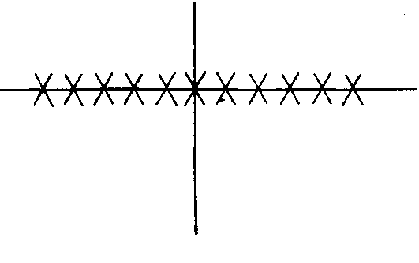 | - Water consists of hydrogen and oxygen.  - Most animals kill only for food.  - The world is round. | The simple present says that something was true in the past, it is true in the present, and will be true in the future. It is used for general statements of fact.
 | - I study for two hours every night.  - My classes begin at nine.  - He always eats a sandwich for lunch. | The simple present is used to express habitual or everyday activity.
 | - I have only a dollar right now.  - I don't recognize that man.  - He needs a pen right now. | Certain verbs are not used in the progressive tenses. With these verbs, the simple present may indicate a situation that exists right now, at the moment of speaking.

PRESENT PROGRESSIVE

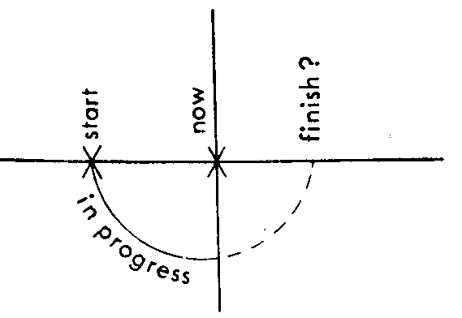 | - John is sleeping right now.  - I need an umbrella because it is raining.  - John and Mary are talking on the phone. | The present progressive expresses an activity that is in progress at the moment of speaking. It began in the recent past, is continuing at present, and will probably end at some point in the future.
 | - I am taking five courses this semester,  - John is trying to improve his work habits.  - She is writing another book this year. | Often the activity is of a general nature: something generally in progress this week, this month, this year.  Note (o): The sentence means that writing a book is a general activity she is engaged in at present, but it does not mean that at the moment of speaking she is sitting at her desk with pen in hand.

VERBS USUALLY NOT USED IN ANY OF THE PROGRESSIVE TENSES

VERB | EXAMPLE | OTHER USES OF THIS VERB
be | (a) I am hungry
SENSES  hear  taste  smell  see | (b) I hear a noise.  (c) This food tastes good.  (d) I smell gas.  (e) I see a butterfly. | You will be hearing from me. (meaning: I will write or phone you.  The doctor is seeing a patient, (meaning: meeting with)
MENTAL ACTIVITY  know  believe  think  understand  recognize  remember  forget  mean | (f) I know his phone number.  (g) I believe his story.  (h) I think he is a kind man. (meaning: believe)  (i) I understand your problem now.  (j) I don't recognize him.  (k) I remember my first teacher.  (1) I forget his name,  (m) I mean this book, not that one. | I am thinking about this grammar, (meaning: Certain thoughts are going through my mind right now.)  I have been meaning to call you. (meaning: intending)
POSSESSION  possess  own  have  belong | (n) He possesses many fine qualities, (o) She owns a house,  (p) He has a car. (meaning: possesses) (q) That belongs to me. | I am having trouble.  He is having a good time.  (meaning: experiencing)
ATTITUDES  Want  prefer  need  appreciate  love  like  hate  dislike  seem | - I want to leave now.  - He prefers to stay here.  - I need some help.  - I appreciate your help.  - I love my family.  - I like this book.  - She hates dishonesty.  - I dislike this book.  - He seems to be a nice person.
VERB  ATTITUDES  look  appear | EXAMPLE  She looks cold.  - (meaning: seems to be)  - He appears to be asleep,  (meaning: seems to be) | OTHER USES OF THIS VERB  I am looking out the window. (meaning: using my eyes to see)  The actor is appearing on the stage.
EXERCISE I
Use either the simple present or the present progressive of the verbs in
parentheses.

1. Kathy (sit, usually) _____________________in the front row in class, but today she (sit) __________________ in the last row.
2. Diane can't come to the phone because she (wash) _________________ her hair.
3. Diane (wash) __________________________her hair every other day or so.
4. Please be quiet. I (try) _____________________________ to concentrate.
5. (Lock, you, always) ________________________ the door to your apartment when you leave?
6. Look! It (snow) _______________________________________________.
7. Mike (go, not) __________________________________ to school right now because it is summer. He (attend) _________________ college from September to May every year, but in the summer he (have, usually) ____________________ a job at the post office. In fact, he (work) ___________________________ there this summer.
8. Right now I (look) _________________________ around the classroom. Ahmed (write) ____________________________ in his book. Carlos (bite)
__________________ his finger nails.

5 Detectives at work
Tom and Nick are watching the house across the street. Something strange is happening.
Put the verbs in brackets in the present simple or the present continuous to make correct sentences.

TOM What are you staring (you stare) at?
NICK There's a man at the Johnsons' house. He doesn't live (not live) there. I wonder what he ¹________________________________(do)
TOM Perhaps he ² __________________________ (visit) the Johnsons.
NICK No. They're not at home. They both _______________________(work) in town. They ⁴_____________________________ (catch) the same train as Dad every morning. It's strange. He ______________________(watch) the house very carefully.
TOM Now he⁶ _______________________ (try) to open the gate, but it's locked. Look! He⁷ ________________________ (climb) over the garden wall. I can't see him now.
NICK Let's follow him. I want to see what he⁸ _______________________(do)
TOM He ⁹ ___________________________(go) to the garage. He 10_________ _____________ (carry) a ladder. Now he ¹¹__________________________(put) the ladder up to the bedroom window!
NICK He must be a burglar. . . Hey! You! What ¹²_______________________(you do)?
MAN It's all right, boys. I'm an insurance agent. 1¹³____________________________ (examine) the roof. The Johnsons ¹⁴______________________ (know) that I'm here.
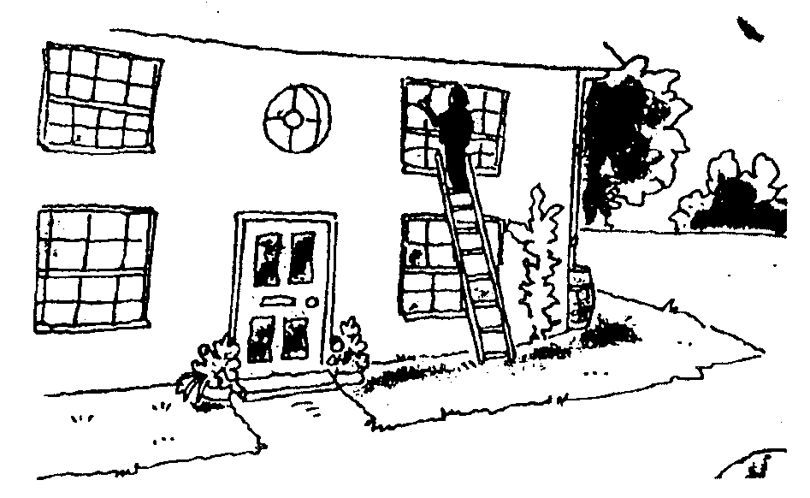

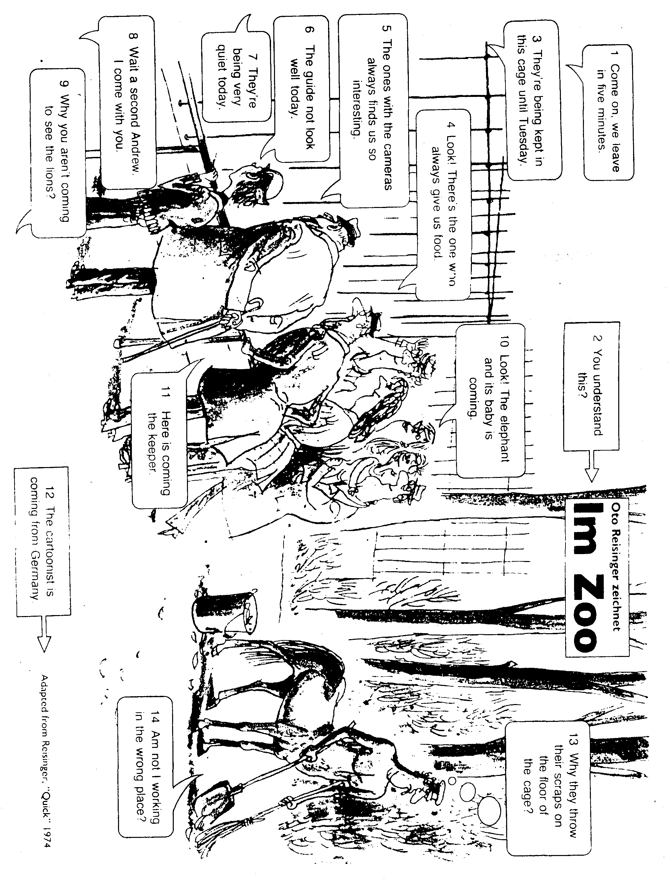

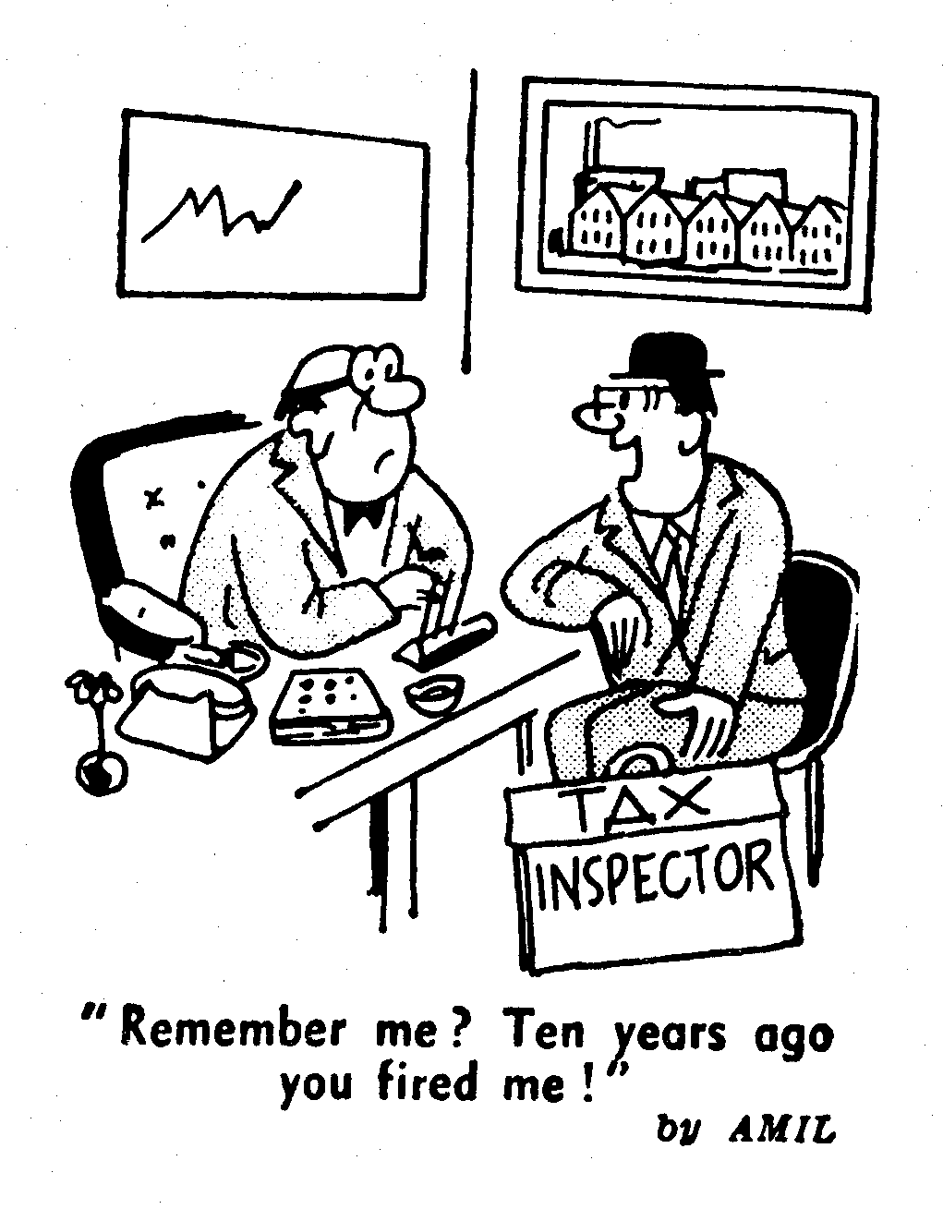
SIMPLE PAST

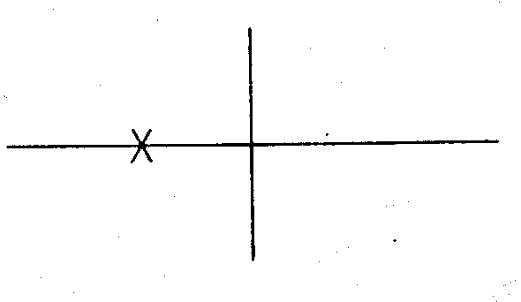 | - I walked to school yesterday.  - He lived in Paris for ten years, but now he is living in Rome.  - I bought a new car three days ago. | The simple past indicates that an activity or situation began and ended at a particular time in the past.
 | - I stood under a tree when it began to rain.  - When she heard a strange noise, she got up to investigate.  - When I dropped my cup, the coffee spilled on my lap. | If a sentence contains when and has the simple past in both clauses, the action in the "when clause" happens first. In (d): 1st: The rain began. 2nd: I stood under a tree.

PAST PROGRESSIVE
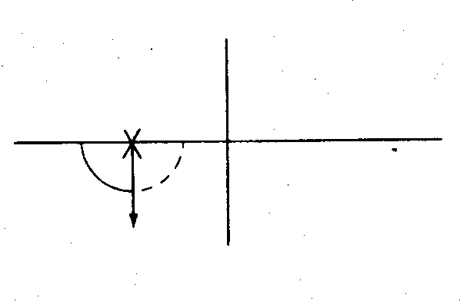 | - I was walking down the street when it began to rain.  - While I was walking down the street, it began to rain.  - I was standing under a tree when it began to rain.  - At eight o'clock last night, I was studying.  - Last year at this time, I was attending school. | In (i): 1st: I was walking down the street.  2nd: It began to rain.  In other words, both actions occurred at the same time, but one action began earlier and was in progress when the other action occurred.  In (1): My studying began before 8:00, was in progress at that time, and .probably continued.
 | - Last January, while you were trudging through snow in Iowa, I was lying on the beach in Florida.  - While I was studying in one room of our apartment, my roommate was having a party in the other room. | Sometimes the past progressive is used in both parts of a sentence when two actions are in progress simultaneously.
 | - It rained this morning.  - It was raining this morning. | In some cases, the simple past and the past progressive give almost the same meaning, as in (o) and (p).

Exercise 1

Use the simple past or the past progressive in the following.

1. I (read) ____________________________ only two chapters last week.
2. I (read) _________________________ a book last night when you called.
3. I (call) _______________________ John at nine last night, but he (be, not) __________________ at home. He (study) ____________________________
at the library.
4. I (hear, not) _______________________ the thunder during the storm last night because I (sleep) _________________________.
5. My brother and sister (argue) _______________________ about something when I (walk) _________________________ into the room.
6. When I (open) ______________________ the package, I (find) ______________ _________ a surprise.
7. He (climb) ________________________ the stairs when he (trip) _____________
and (fall) _______________________. Luckily, he (hurt, not) __________________ himself.
8. While I (read) ___________________________ the little boy a story, he (fall) _________________________ asleep, so I (close) __________________________
the book and quietly (tiptoe) __________________________ out of the room.
Exercise 2
How jeans came to America
Put the verbs in brackets in the past simple or past continuous.
Levi Strauss came (come) from a small town in the south of Germany. When he ¹. ___________ (be) a young man, he² __________________ (fall) in love with the mayor's daughter.
But the mayor and Levi's parents ³ _______________________(not want) them to marry.
Levi's parents ⁴_____________________ (send) him away to New York where his brothers ⁵________________________ (live). They⁶ ______________________ (be) tailors and they⁷____________________ (teach) him to sew. In 1850, Levi _______________________ (take) some sailcloth from New York to San Francisco when he _________________________ (meet) some men. They
10 _____________________________(dig) for gold in the streams and rivers. The weather was bad. It ________________________ (rain) and the wind12 _____________________________ (blow). The men were cold because they (wear)¹³ ___________________________thin trousers.
Suddenly Levi 14______________________(have) an idea. He ¹⁵ ____________ (use) the sailcloth which he16 _____________________ (transport) to make trousers for the men. Then he 17___________________________________(sew) on metal studs to
make them stronger.
The men 18 ____________________________ (love) the trousers but they 19________________________________________(not like) the yellow-grey colour. So when Levi Strauss 20______________________(open) a tailor's shop in San Francisco, he 21
_______________________ (import) a special thick blue material from Nimes in France. That's how jeans 22 _________________________(become) blue.

Exercise 3 Where did he come from?
Use the words in brackets to write questions about Levi Strauss. He came from Germany. (Where ...................from)
'Where did he come from?
1 His parents sent him to America. (Where)
________________________________________________________________
2 His brothers taught him to sew. (What)
________________________________________________________________
3 In 1850 he set out for San Francisco. (When)
________________________________________________________________
4 He met some prospectors on the way. (Who)
_________________________________________________________________
5 They were digging in a river. (Where)
_________________________________________________________________
6 They were wearing thin trousers. (What)
_________________________________________________________________
7 He was taking sailcloth to California. (What)
_________________________________________________________________
8 He made trousers from the sailcloth. (What. . from)
_________________________________________________________________
9 The men didn't like the colour. (Why)
________________________________________________________________
10 He imported blue material from France. (Where... from)
_________________________________________________________________
Exercise 4 PAST SIMPLE - PAST CONTINUOUS
1. When she ___________________________the dishes she ________________ a big plate. (dry / drop)
2. While they _________________________ TV, a thief _________________ in.
(watch / climb)

3 Mother _________________________ dinner, while we _______________ our
homework. (cook / do)
4. The pupils ________________ cards, when their teacher _________________ (play / enter)
5. Mother _________________ the clothes, when the lights _________________ out (iron / go)
6. The postman ________________ the parcel, just as they _________________ (bring / leave)
7. Susan ________________ her purse, while she _________________________ (lose / shop)
8. We __________________a song, when our headmaster ____________________ (sing / enter)
9. When he ____________________ to town, he __________________________ an accident (drive / have)
10. Mother ______________________ a cake, while we _____________________ in the garden. (bake / play)
11. As I _________________ down the street, a car __________ into the shop.
(walk / crash)
12. While we __________________ TV, a thief _____________ our car.
(watch / steal)
13. The burglar ________________ the safe, when he _________ some footsteps, (open/hear)
14. Father _______________ the newspaper, when the doorbell ______________. (read / ring)

Exercise 5
PAST SIMPLE - PAST CONTINUOUS (2)
1. We ___________________________________TV last night. (watch)
2. The train ___________________________________ at 6.30. (leave)
3. Mother ____________________________the dishes - (wash) when the phone _____________________________. (ring)
5. We ________________________________ a nice party last Saturday, (have)
6. In 55 B. C. Julius Caesar _____________________________to Britain. (come)
7. Father ________________________________in his car - (wait) while mother ____________________. (shop)
9. I couldn't come, because I _________________________________ ill. (be)
10. Just as he ___________________________________to bed, (go)
the lights __________________________out. (go)
12. The car suddenly _________________________________________. (stop)
13. It ________________________(rain) when he_____________________ out of the window. (look)
15. Father ____________________________ home yesterday. (not come)
He ______________________________ lunch in a restaurant. (have)
16. I ________________________________ through the window. (look)
Some students _______________________________ on the blackboard, (write)
17. We _____________________________an English song, (sing) when the door
__________________________ . (open)
18. Mother _______________________________ the rooms last Saturday. (clean)
19. They _____________________ that school, (build) when I _________________
a little boy. (be)

20. Some people in the waiting-room __________________________ (read).
Suddenly the door ___________________ (open) and the nurse
________________ (say), "The next one, please”.
21. The dog ________________________________ the postman (attack).
just as he _________________________ letters into the letter-box. (put)
22. How ___________you _____________your leg? (break) I ________________
off the ladder, (fall) when I ________________ some apples. (pick)
23. We ___________________________much sleep last night, (not get) because
our neighbours ________________________________a party . (have)
24. You are late. The train ________________________________ at 8.00. (leave)
25. They _________________________________ to Canada some years ago. (go)
26. I ___________________________ my homework (do) when my friend Peter ____________________. (turn up)
27. They __________________tea (have) when the doorbell __________________ . (ring)
GRAMMAR WITH LAUGHTER
Past Simple / Continuous
Complete the jokes below by using the correct tense of the verb in brackets:
- Dad. What do you call a small brown thing with ten legs, and green eyes?
I don't know, son. Why do you ask?
Well, one .......................................... along your lettuce just before you …………........... it! (crawl, eat)
- Harry ........................................................ a large grandfather clock on his shoulder, (carry) He was delivering it to a customer. He couldn't see what was on his right hand side and he .................................................over an old lady who ............................... in a shop window, (knock, look) "I'm very, very sorry, "said the man.
"Idiot!" shouted the old woman. "Why can't you wear a watch like everybody else?"
- What .............................. you …………….......... in my apple tree last night, young man? (do)
Well, one of your apples ................................ down when I ............................ your garden so I……………………………………......... it back for you! (fall, pass, put)
- Magic Bob was a magician on a cruise ship. Each night he took objects from the passengers and made them disappear, then reappear in strange places. The captain of the ship had a parrot which always shouted "Rubbish!" at the end of the magician's act. One day the ship ................................... an iceberg and ……………. .......... . (hit, sink) The magician and the parrot were the only survivors. While they ............................. on a large piece of wood in the water, the parrot ……………………………............ (lie, say) "OK, genius. Where's the ship?"
- A lifeguard ................................................. a young lady the kiss of life when her husband ..................................... (give, arrive).
What are you doing to my wife?
I'm giving her artificial respiration.
Artificial! Give her the real thing. I'll pay for it.
- Doctor, lots of my hair ........................................... out while I .................................. it this morning, (fall, brush)
Have you got anything for it?
Sure. Here's a box.
- A young man was in the middle of a road with his right ear to the ground. An old lady asked him:

What are you listening for?
A motorbike passed this spot ten minutes ago.
That's incredible! How do you know that?
Because it ................................... me while I ............................. the road and it................. my neck. (hit, cross, break)
- How did you get that big red lump on your nose?
I................................a brose while I ............................... in the garden, (smell, work)
But there is no 'b' in rose.
There was in this one!

Talk or write about accidents you had, while you were doing something else. For example: I cut (past simple) my hand badly while I was peeling (past continuous) some potatoes. I scraped the side of my car while I was parking in town.
UPS & DOWNS
- swim  - rise  - come  - drink, throw  - fight  - keep  - buy  - light  - think  10.find | - bite  - hear  - bring  - send  - wear  - know  - draw,  hide  - leave  - ring  - begin | - beat  - do  - take  - drive  - grow  - tell  - run  - catch  - get  - cut | - lay  - teach  - have  - sell  - show  - build  - let  - blow  - spend  - read | - make  - shut  - sit  - hold  - win  - lose  - fall  - sing  - meet  - weep

100  FINISH | 99  DOWN |  | 98 | 97 |  | 96  DOWN | 95 |  | 94 | 93 |  | 92 | 91
81 | 82 |  | 83 | 84 |  | 85 | 86  UP |  | 87 | 88 |  | 89 | 90
80 | 79 |  | 78 | 77 |  | 76 | 75 |  | 74 | 73  DOWN |  | 72 | 71
61 | 62 |  | 63 | 64 |  | 65  UP | 66 |  | 67 | 68 |  | 69 | 70
60 | 59  UP |  | 58 | 57 |  | 56 | 55 |  | 54 | 53 |  | 52  UP | 51
41 | 42 |  | 43 | 44 |  | 45 | 46 |  | 47  UP | 48 |  | 49 | 50
40 | 49 |  | 38 | 37 |  | 36  UP | 35 |  | 34 | 33 |  | 32 | 31
21 | 22  DOWN |  | 23 | 24 |  | 25 | 26  UP |  | 27 | 28 |  | 29 | 30
20 | 19 |  | 18 | 17  UP |  | 16 | 15 |  | 14 | 13  UP |  | 12 | 11
1  START | 2 |  | 3 | 4 |  | 5 | 6  UP |  | 7 | 8 |  | 9 | 10
- give  - eat  - lie  - shine  - wake  - write  - feed  - freeze,sweep  - pay  - strike |  | - fly  - break  - go  - forget  - say  - feel  - ride  - mean  - become  - stand |  |  | - speak  - see  - put  - be  - choose  - dig  - knee  - lead  - sew  - hit |  |  | - sleep  - forbid  - spread  - shake, lend  - shrink  - forgive  - steal  - cost, hurt  - swing  - shoot |  |  | - tear  - spit  - spring  - spin  - undertake  - understand  - swear  - stick  - sink
Irregular verbs

- swim - swam - swum (schwimmen)
- rise - rose – risen (erheben)
- come - came – come (kommen)
- drink - drank – drunk (trinken)
throw - threw – thrown (werfen)
- fight - fought – fought (kämpfen)
- keep - kept – kept (halten)
- buy - bought – bought (kaufen)
- light - lit – lit (leuchten)
- think - thought – thought (denken)
- find - found – found (finden)
- bite - bit – bitten (beißen)
- hear - heard – heard (hören)
- bring - brought – brought (bringen)
- send - sent – sent (schicken)
- wear - wore – worn (tragen)
- know - knew – known (wissen)
- draw - drew – drawn (zeichnen)
hide - hid – hidden (verstecken)
- leave - left – left (verlassen)
- ring - rang – rung (lauten)
- begin- began – begun (anfangen)
- beat - beat – beaten (schlagen)
- do - did – done (tun)
- take - took – taken (nehmen)
- drive - drove – driven (lenken)
- grow - grew – grown (wachsen)
- tell - told – told (erzählen)
- run - ran – run (rennen)
- catch - caught – caught (fangen)
- get - got – got (bekommen)
- cut - cut – cut (schneiden)
- lay - laid – laid (legen)
- teach - taught – taught (lehren)
- have - had – had (haben)
- sell - sold – sold (verkaufen)
- show - showed – shown (zeigen)
- build - built – built (bauen)
- let - let – let (lassen)
- blow - blew – blown (blasen)
- spend - spent - spent(verbringen)
- read - read - read(lesen)
- make - made – made (machen)
- shut - shut- shut (schließen)
- sit - sat – sat (sitzen)
- hold - held – held (halten)
- win - won – won (gewinnen)
- lose - lost – lost (verlieren)
- fall - fell – fallen (fallen)
- sing - sang – sung (singen)
- meet - met – met (treffen)
- weep - wept – wept (weinen)
- give – gave - given (geben)
- eat - ate - eaten (essen)
- lie - lay - lain (liegen)
- shine - shone - shone (scheinen)
- wake - woke - woken (aufwachen)
- write - wrote - written (schreiben)
- feed - fed - fed (futtern)
- freeze - froze - frozen (frieren)
sweep - swept - swept (kehren)
- pay - paid - paid (bezahlen)
- strike - struck - struck (schlagen)
- fly - flew - flown (fliegen)
- break - broke - broken (brechen)
- go - went - gone (gehen)
- forget - forgot - forgotten (vergessen)
- say - said - said (sagen)
- feel - felt - felt (fühlen)
- ride - rode - ridden (reiten)
- mean - meant - meant (meinen)
- become - became - become (werden)
- stand - stood - stood (stehen)
- speak - spoke - spoken (sprechen)
- see - saw - seen (sehen)
- put - put - put (setzen)
- be - was/were - been (sein)
- choose - chose - chosen (wahlen)
- dig - dug - dug (graben)
- kneel - knelt - knelt (knien)
- lead - led - led (fuhren)
- sew - sewed - sewn (nahen)
- hit - hit - hit (schlagen)
- sleep - slept - slept (schlafen)
- forbid - forbade - forbidden
(verbieten)
- spread - spread - spread (verbreiten)
- shake - shook - shaken (schütteln)
lend - lent - lent (leihen)
- shrink - shrank - shrunk (schrumpfen)
- forgive - forgave - forgiven (vergeben)
- steal - stole - stolen (stehlen)
- cost - cost - cost (kosten)
hurt - hurt - hurt (verletzen)
- swing - swung - swung (schwingen)
- shoot - shot - shot (schießen)
- tear - tore - torn (reißen)
- spit - spat - spat (spucken)
- spring - sprang - sprung (springen)
- spin - spun - spun (spinnen)
- undertake -undertook -undertaken
(unternehmen)
- understand - understood - understood
(verstehen)
- swear - swore - sworn (schworen)
- stick - stuck - stuck (kleben)
- sink - sank - sunk (sinken)

 | 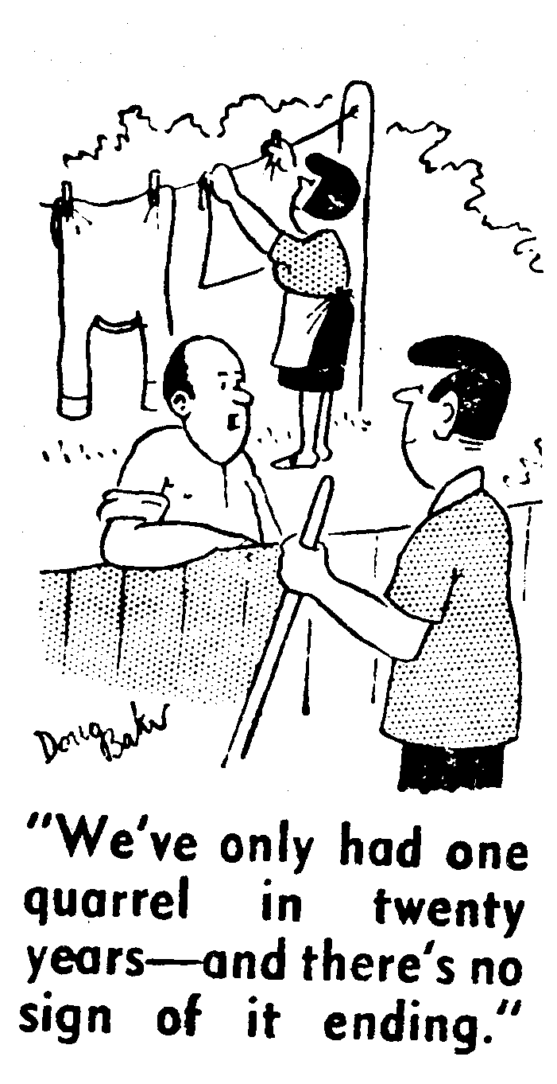  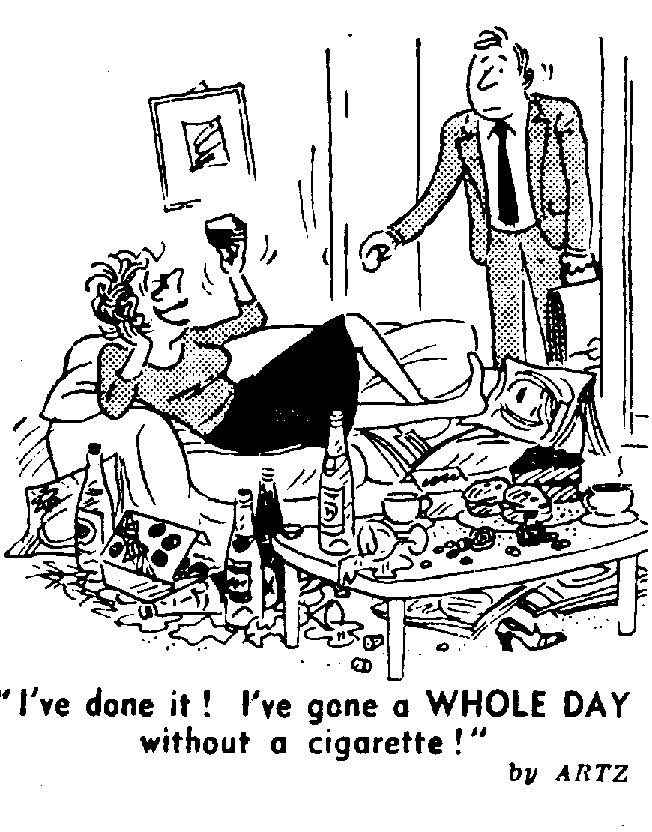

PRESENT PERFECT

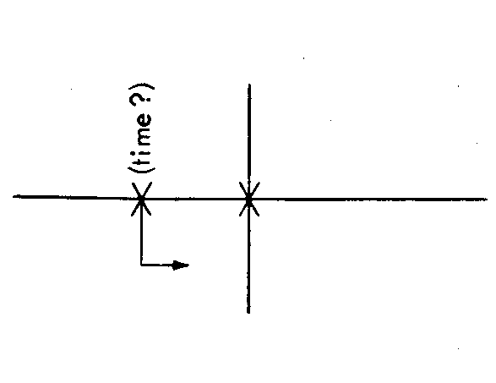 | - They have moved into a new apartment.  - Have you ever visited Mexico?  - I have already seen that movie.  - I have never seen snow. | The present perfect expresses the idea that something happened (or never happened) before now, at an unspecified time in the past. The exact time it happened is not important.  If there is a specific mention of time, the simple past is used: I saw that movie last night.
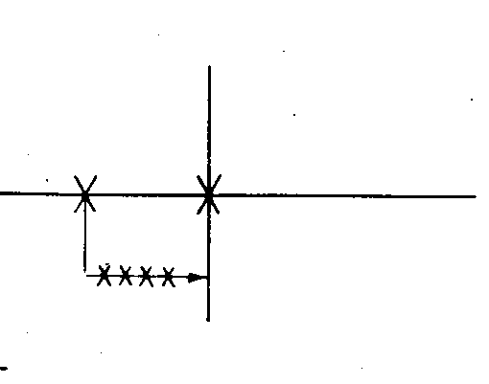 | - We have had four tests so far this semester.  - I have written my wife a letter every other day for the last two weeks.  - I have met many people since I came here in June.  - I have flown on an airplane many times. | The present perfect also expresses the repetition of an activity before now. The exact time of each repetition is not important.

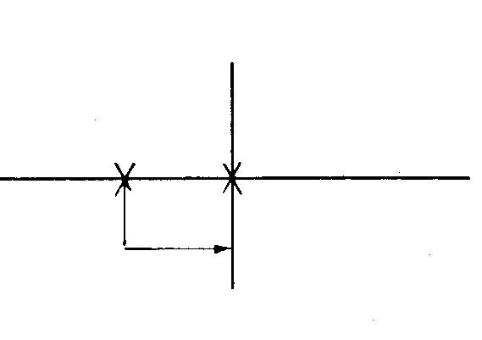 | - I have been here since seven o'clock.  - We have been here for two weeks,  - I have had this same pair of shoes for three years.  - I have liked cowboy movies ever since I was a child,  - I have known him for many years. | The present perfect also, when used with for or since, expresses a situation that began in the past and continues to the present.*  In the examples, notice the difference between since and for:  since + a particular time  for + duration of time

The present perfect has this meaning primarily for those verbs that are usually not used in any of the progressive tenses. This meaning is exactly the same as the meaning of the present perfect progressive tense.

PRESENT PERFECT PROGRESSIVE

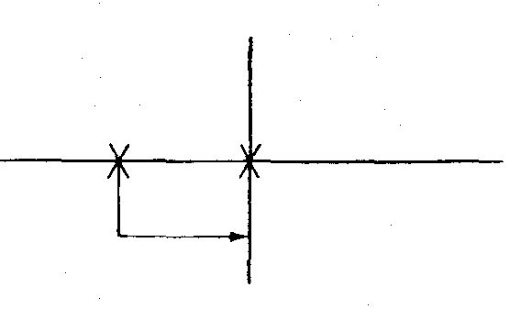 | Right now I am sitting at my desk.  (a) I have been sitting here since seven o'clock.  (b) I have been sitting here for two hours.  (c) You have been studying for five straight hours. Why don't you take a break?  (d) He has been watching television since nine o'clock this morning.  (e) It has been raining all day. It is still raining right now. | This tense is used to indicate the duration of an activity that began in the past and continues to the present. When the tense has this meaning, it is used with time words such as for, since, all morning, all day, all week.
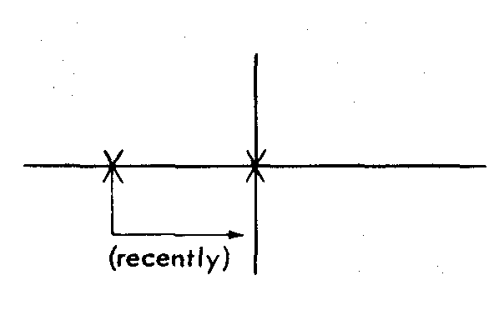 | - I have been thinking about changing my major.  - All of the students have been studying hard.  - John has been doing a lot of work on his thesis. He should be finished by May.  - My back hurts, so I have been sleeping on the floor lately. The bed is too soft. | When the tense is used without any specific mention of time, it expresses a general activity in progress recently, lately.
 | - I have lived here since 1975.  - I have been living here since 1975.  - He has worked at the same store for ten years. | With certain verbs (most notably live, work, teach) there is little or no difference in meaning between the two tenses when since or for is used.

Exercise 1:
Use the simple past or the present perfect. In some sentences either tense is possible but the meaning is different.
- I (not attend) ________________________________ any parties since I came here.
- I (go) ________________to a party at Sally's apartment last Saturday night.
- Bill (arrive) ____________________________here three days ago.
- Bill (be) _______________________________________here since the 22nd.
- Try not to be absent from class again for the rest of the term. You (miss, already) _______________________________ too many classes. You (miss) __________________________________ two classes just last week.
- Last January, I (see) ____________________ snow for the first time in my life.
- In her whole lifetime, she (see, never) ______________________snow.
- I (know) _______________________________ Greg Adams for ten years.
- So far this week, I (have) _________________________ two tests and a quiz.
- Up to now, Professor Williams (give) ________________ our class five tests.
- The science of medicine (advance) _________________ a great deal in the 19th century.
- Since the beginning of the 20th century, medical scientists (make) ____________________ many important discoveries.
Exercise 2:
Use the present perfect progressive in the following.
- The boys are playing soccer right now. They (play) have been playing for almost two hours. They must be getting tired.
- Alex is talking on the phone. He (talk) _________________on the phone for over a half an hour. He should hang up soon. Long distance is expensive.
- I'm trying to study. I (try) __________________to study for the last hour, but something always seems to interrupt met I think I'd better go to the library.

Complete the following by writing two sentences. Use the present perfect progressive in the first sentence; then make another sentence that might typically follow in this situation.

4. The baby is crying. She Has been crying for almost ten minutes.
I wonder what's wrong.

5. It's raining. It ______________________________________________________________
___________________________________________________________________________
6. I'm studying. I _____________________________________________________________
___________________________________________________________________________
7. I'm waiting for my friend. I ___________________________________________________
___________________________________________________________________________
8. Bob is sitting in the waiting room. He __________________________________________
___________________________________________________________________________
Exercise 3:
Use the present perfect or the present perfect progressive. In some sentences, either tense may be used with little or no change in meaning.

- It (snow) ___________________________all day. I wonder when it stops.
- We (have) __________________three major snowstorms so far this winter. I wonder how many more we will have.
- It's ten p.m. I ______________________(study) for two hours and probably won't finish until midnight.
- I (write) ______________________ them three times, but I still haven't received a reply.
- I (live) ______________________ here since last March.
- The telephone (ring) _______________________ four times in the last hour, and each time it has been for my roommate.
- The telephone (ring) ____________________ for almost a minute. Why doesn't someone answer it?
- The little boy is dirty from head to foot because he (play) ____________ in the mud.
Exercise 4:
Same as the preceding exercise.
- A: (Be, you) ________________ able to reach Bob on the phone yet? B: Not yet. I (try)________________for the last twenty minutes, but the line (be) __________busy.
- A: Hi, Jenny. I (see, not) _______________you for weeks. What (do, you) _________________________ lately? B: Studying.
3. A: What are you going to order for dinner?
B: Well, I (have, never) _______________pizza, so I think I'll order that.
4. A: What's the matter? Your eyes are red and puffy. (Cry, you)______________________?
B: No. I just finished peeling some onions.
- A: Dr. Jones is a good teacher. How long (be, he) _______________at the university?
B: He (teach) ____________________here for twenty-five years.

Exercise 5: What have they been doing?
Complete the sentences with the present perfect simple or the present perfect continuous.
Jane has been writing (write) a letter to a magazine. She hasn't finished it yet.
- Ben _____________________(look) for his pen-knife, but he hasn't found it yet.
- Jenny ___________________ (wait) for the bus for half an hour, but it hasn't arrived yet.
- Nick _________________ (play) a computer game for two hours and he's still playing.
- Mike hasn't finished painting his car yet. He __________________ (work) on it for two weeks.
- Amanda _________________(not come) home yet. She has been shopping in town since 10 o'clock.
- Mike's car ________________(make) strange noises. Nick and Jane have cleaned all the parts.
- Ben has been drawing cartoons for two hours. He _________________ (not finished) yet.
- Amanda has been waiting for Jenny in town. Jenny _________________ (not arrive) yet.
- Jane has been knitting a pullover. She ______________________ (just finish) it.
- It ___________________ (rain) all day and it hasn't stopped yet.
- Mr Blake has been marking tests all evening but he ______________ (not find) a perfect one yet.
- Trig ____________________(practise) the present perfect, but he hasn't got it right.

Think of a job or activity that you have started but have not finished, for example, something that you are making, reading or drawing. Write a short paragraph about it. Say how long you have been doing it.

GRAMMAR WITH LAUGHTER Present Perfect / Past Simple
Using the Present Perfect or the Past Simple, complete the following jokes:
- …. ................. you .................................. (be) to America before?
No. This is my first time.
Did you know that Christopher Columbus .................................................. (find) America?
Really? I never knew it was lost!
- When you ........................... (sell) me this car this morning, you .............................. (say) it was trouble-free. Since then, the brakes ........................ (fail) and the door ................... (fall) off.
Well, sir, I did sell you the car but the trouble was free!
- Doctor, I ............................... (have) a sore stomach ever since I ......................... (eat) three crabs last week.
……………....... they .................................. (smell) bad when you ............................ (take) them out of their shells?
What do you mean - took them out of their shells?
- Now, ......................... everyone ......................... (read) the chapter on Lord Nelson for homework?
Yes, sir.
Kevin,. in which battle ................................ Lord Nelson ..................................... (die)?
Er, his last one, sir?
- I ............................... (buy) this diamond ring from a man in the street. It's for my girlfriend.
Are they real diamonds?
I hope so. If not, the man ................................... just.......................... (cheat) me out of £5.
- How's your sister?
She .......................................... (go) on a very strict diet to lose weight.
And how is she getting on?
Fine. She .................................................................. (disappear) last week.
- Mrs Smith is very upset. She thinks she .............................. (lose) her cat.
When ................................... she last............................. (see) it?
Four days ago.
Why doesn't she put an advertisement in the newspaper?
Don't be silly. Her cat can't read.
- My dad ....................... never ................................ (visit) the dentist.
My dad will never go back to the dentist.
Why? What happened?
The dentist.................................................... (take) all his teeth out.
What........................... your dad ......................... (say)?
Never again! Never again!
- Robert was fishing in a private lake. An old man came up to him and asked:
……….......... you ………………………........ (catch) anything?
Yes. Three big fish since I ........................................... (start) this morning.
My name is Lord Arton and I own this lake. Oh. My name is Robert and I'm a terrible
liar!

Past Perfect

A beggar stopped me the other day and said he hadn’t had a bite for days.
What did you do?
I bit him!
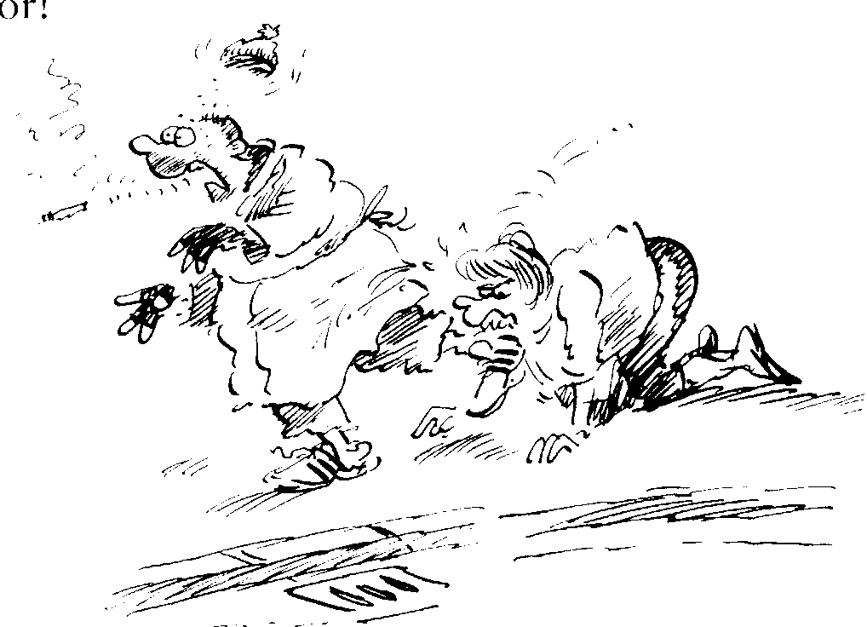
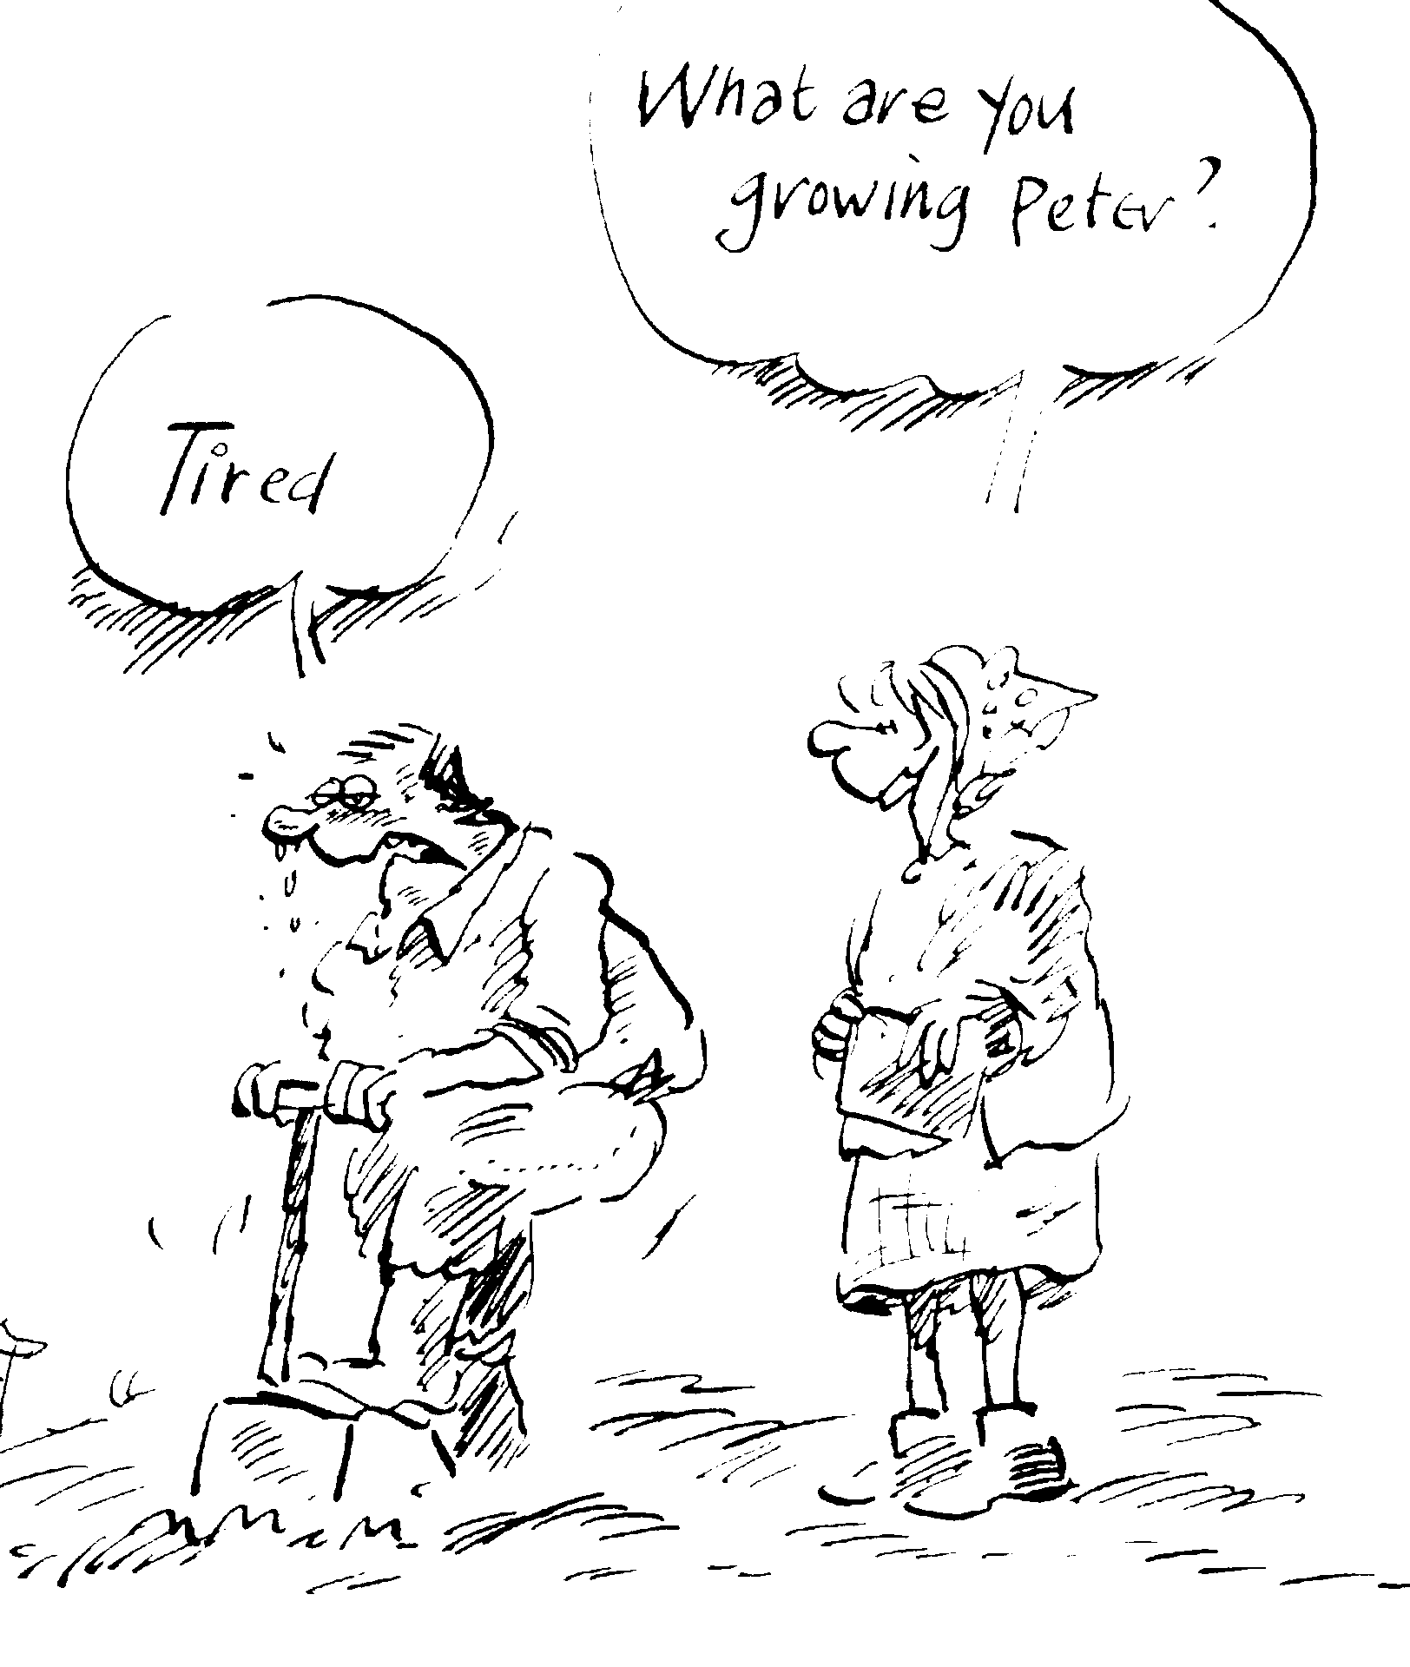 | Peter had a very large garden and he had been digging it for about five hours when Mrs. Burns came along.  Oh, hello, Peter. What are you growing?  The sweat was running down Peter’s face.  He looked up and said, “Tired!”
PAST PERFECT

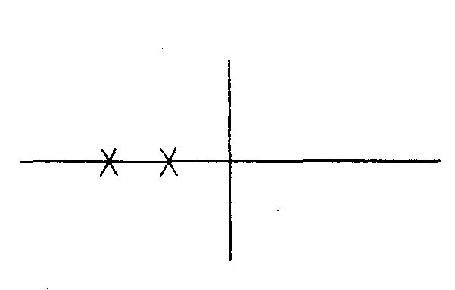 | - My parents had already eaten by the time I got home.  - Until yesterday, I had never heard about it.  - The thief simply walked in. Someone had forgotten to lock the door.  - He had arrived before we got there.  - He arrived before we got there.  - After the guests had left, I went to bed.  - After the guests left, I went to bed. | The past perfect expresses an activity that was completed before another activity or time in the past.  If either before or after is used in the sentence, the past perfect is not necessary because the time relationship is already clear. The simple past may be used instead of the past perfect, as in (e) and (g).

PAST PERFECT PROGRESSIVE

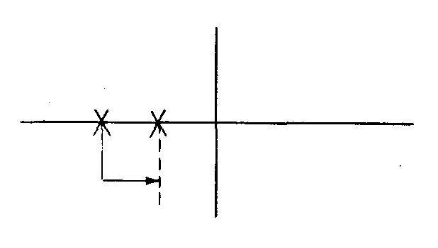 | - The police had been looking for the criminal for two years before they caught him.  - The patient had been waiting in the emergency room for almost an hour before a doctor finally treated her.  - He finally came at six o'clock. I had been waiting for him since four-thirty.  - Her skin was sunburned because she had been lying on the beach all afternoon. | The past perfect progressive emphasizes the duration of an activity that was in progress before another activity or time in the past.
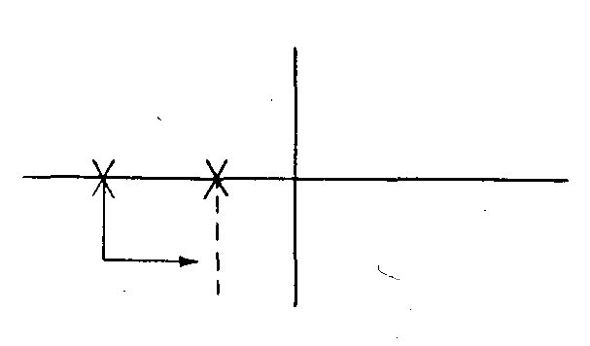 | - When Judy got home, her hair was still wet because she had been swimming.  - Her eyes were red because she had been crying. | This tense also may express an activity in progress recent to another time or activity in the past.

Exercise 1: Use Simple Past or the Past Perfect
Are there some sentences where either tense is possible?

- He (be) _____________________________________ a newspaper reporter before he (become) _______________________a business man.
- I (feel) ________________________ a little better after I (take) __________ the medicine.
- I was late. The teacher (give, already) _______________________a quiz when I (get) ____________ to class.
- The anthropologist (leave) ______________________the village when she (collect) _________________ enough data.
- It was raining hard, but by the time class (be) _________________over, the rain (stop) ____________________.
- Millions of years ago, dinosaurs (roam) _______________________ the earth, but they (become) __________________extinct by the time humankind first (appear) ______________________.
- Class (begin, already) _______________ by the time I (get) _______________ there, so I (take, quietly) ___________________ a seat in the back.
- I (see, never) _________________________any of Picasso's paintings before I (visit) _______________ the art museum.
- I almost missed my plane. All of the other passengers (board, already) ________________ by the time I (get) _______________________ there.
- Yesterday at a restaurant, I (see) _____________________ Pam Donnelly, an old friend of mine. I (see, not) ___________________________her in years. At first, I (recognize, not) _______________________her because she (lose) ________________at least fifty pounds.
GRAMMAR WITH LAUGHTER The Past Perfect
Use had or hadn't to complete the following:
- When her daughter arrived home from a party, Mrs Thompson asked her if she (thank) ______________ her hostess. "No," she said. "The girl in front of me thanked her and the lady said 'Don't mention it' so I didn't."
- Here's your coffee, madam - it's a special coffee all the way from Brazil. Oh, I was wondering where you (go) ________________.
- A stressed managing director went to his doctor for help in getting to sleep. The workers at his factory (go) ____________ on strike. They wanted better pay and conditions. The director (try) ____________ sleeping pills but they (not work) ____________. The doctor asked the director to lie quite still in bed at night and to count sheep. The following day the director returned to the doctor's surgery.
Well, said the doctor. Any success?
I'm afraid not, he said. By the time I (count) ____________ the thirty-first sheep they (all
go) ______________ on strike for shorter hours and lower fences.
- Kenneth is so stupid. He phoned his teacher at school yesterday to say he couldn't come to school because he (lose) _________________ his voice!
- A doctor (just give) _____________ a boy an injection in his arm. He was about to put a bandage on his arm when the boy said, Would you mind putting the bandage on my other arm, doctor?
Why? I'm putting it over your vaccination so that the other boys will know not to bang
into It.
You don't know the boys in my school, doctor!
- Mum! Mum! Dad's fallen over a cliff. Is he okay? I don't know. He (not stop) _________________ falling when I left.
- A beggar stopped me the other day and said he (not have) ____________ a bite for days.
What did you do? I bit him!
- It was my grandmother's birthday yesterday. Is she old?
Well, by the time we lit the last candle on her birthday cake, the first one (go) _______
out!
- Harry Smith was sent to Central Africa by his company. He sent a postcard to his wife as soon as he arrived. Unfortunately it was delivered to another Mrs. Smith whose husband (die) _________________ the day before. The postcard read: ARRIVED SAFELY THIS MORNING. THE HEAT IS TERRIBLE.

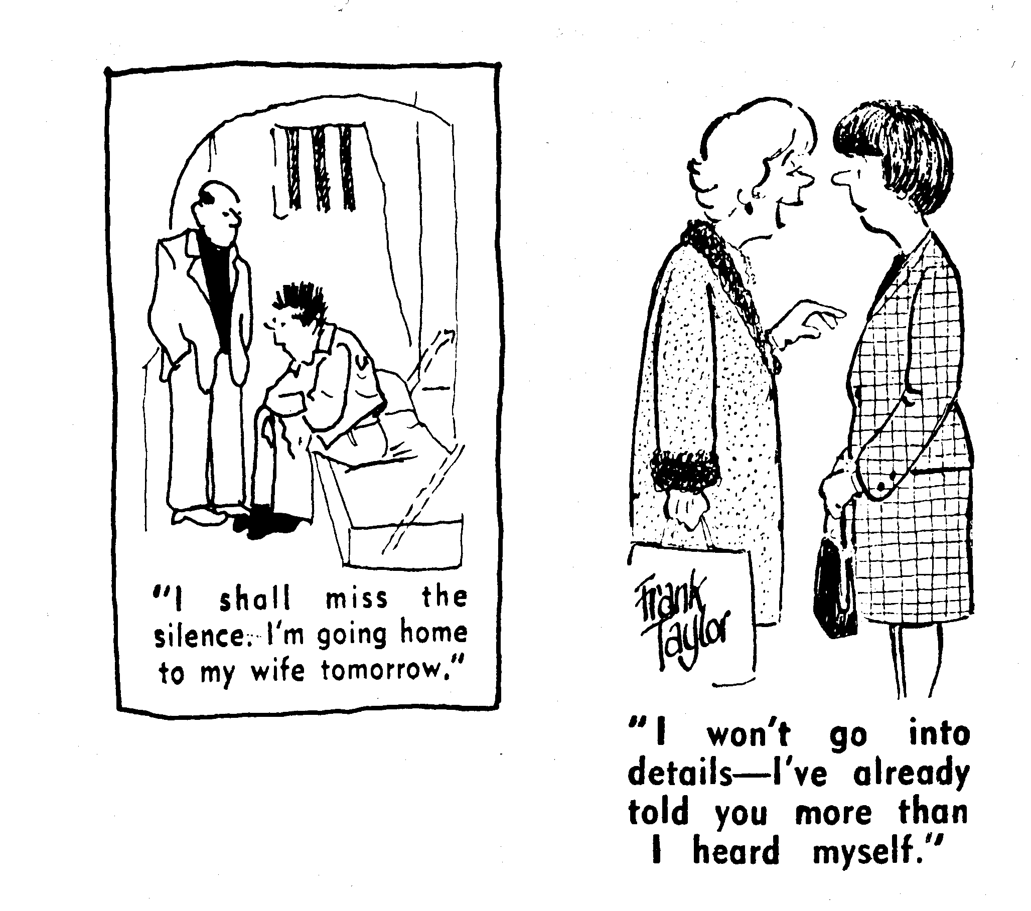
SIMPLE FUTURE / BE GOING TO
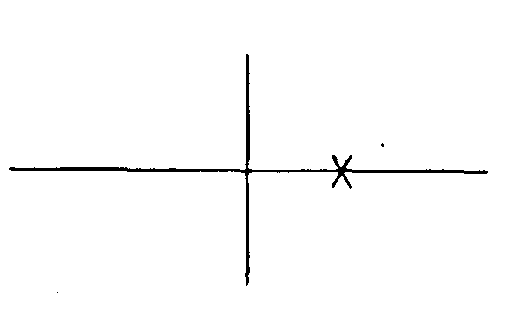 | - He will finish his work tomorrow.  - He is going to finish his work tomorrow.  - I will wash the dishes later.  - I am going to wash the dishes later. | Will or be going to is used to express future time. Shall may be used with I or we, but wil l /be going to is more commonly used.* In speech, going to is often pronounced "gonna."
 | - Bob will come soon. When Bob comes, we will see him.  - Linda will leave soon. Before she leaves, she is going to finish her work.  - I will get home at 5:30. After I get home, I will eat dinner.  - The taxi will arrive in less than five minutes. As soon as the taxi arrives, we will be able to leave for the airport.  - They are going to come soon. I will wait here until they come. | A clause is a grammatical structure which has a subject and a verb. A "time clause" begins with such words as when, before, after, as soon as, until,  These words may be followed by a subject and verb:  When he comes, we will see him. When + subject + verb = time clause  A future tense is not used in a time clause. The meaning of the clause is future, but the simple present tense is used.
 | - I will go to bed after I finish my work.  - I will go to bed after I have finished my work. | Occasionally, the present perfect is used in a time clause, as in (k). Examples (j) and (k) have the same meaning. The present perfect stresses the completion of the act in the time clause before the other act occurs in the future.

ShaIl is used much more frequently in British English than in American English.

USING THE PRESENT PROGRESSIVE AND THE SIMPLE PRESENT TO EXPRESS FUTURE TIME

PRESENT PROGRESSIVE  - My wife has an appointment with a doctor. She is seeing Dr. North next Tuesday.  - Sam has already made his plans. He is leaving at noon tomorrow.  - A: What are you going to do this  afternoon?  B: After lunch I am meeting a friend  of mine. We are going shopping.  Would you like to come along?  d. A: My car is in the garage for repairs.  B: How are you going to get to work  tomorrow?  A: I am taking the bus. | The present progressive may be used to express future time when the idea of the sentence concerns a planned event or definite intention.  (COMPARE: A verb such as rain is not used in the present progressive to indicate future time because rain is not a planned event.)  A future meaning for the present progressive tense is indicated either by future time words in the sentence or by the context.
SIMPLE PRESENT  - The museum opens at ten tomorrow morning.  - Classes begin next week.  - John's plane arrives at 6:05 next Monday. | Sometimes the simple present is used in sentences that contain future time words. The simple present is used primarily with verbs such as open/close, begin/end, arrive/leave and expresses an established fact.  (Note: In expressing future time, the present progressive is used in a much wider range of situations than the simple present.)

FUTURE PROGRESSIVE
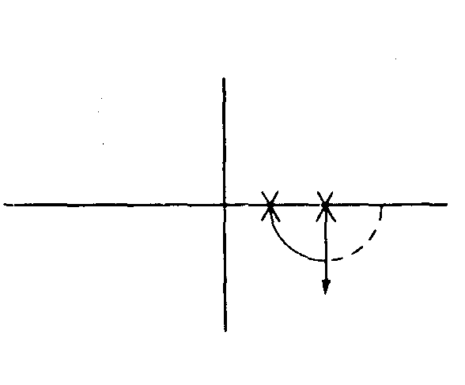 | - I will begin to study at seven. You will come at eight. I will be studying when you come.  - Right now I am sitting in class. At this same time tomorrow, I will be sitting in class. | The future progressive expresses an activity that will be in progress at a time in the future.
 | - Don't call me at nine because I won't be home. I am going to be studying at the library. | The progressive form of be going to:  be going to + be + -ing
 | (d) Don't get impatient. She will be coming soon, (e) Don't get impatient. She will come soon. | Sometimes there is little or no difference between the future progressive and the simple future, especially when the future event will occur at an indefinite time in the future, as in (d) and (e).

FUTURE PERFECT
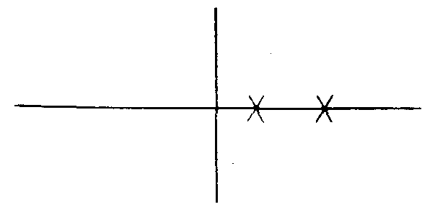 | - I will graduate in June. I will see you in July. By the next time I see you, I will have graduated.  - I will have finished my homework by the time I go out on a date tonight. | The future perfect expresses an activity that will be completed before another time or event in the future.  (Notice in the examples: by the time introduces a "time clause"; the simple present is used in a "time clause.")

FUTURE PERFECT PROGRESSIVE
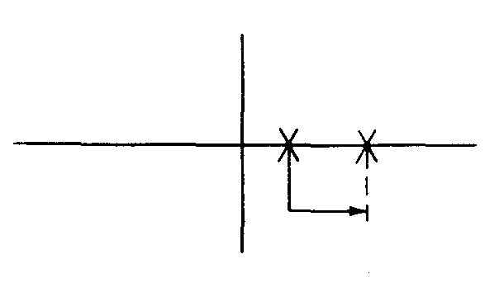 | - I will go to bed at ten P.M. He will get home at midnight. At midnight I will be sleeping. I will have been sleeping for two hours by the time he gets home. | The future perfect progressive emphasizes the duration of an activity that will be in progress before another time or event in the future.
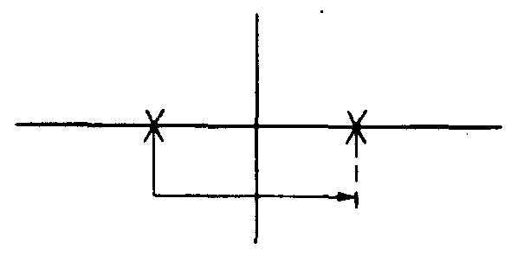 | - When Professor Jones retires next month, he will have taught for 45 years.  - When Professor Jones retires next month, he will have been teaching for 45 years. | Sometimes the future perfect and the future perfect progressive give the same meaning, as in (d) and (e). Also, notice that the activity expressed by either of these two tenses may begin in the past.
Usually there is little or no difference in meaning between will and be going to. Will and be going to indicate inevitability (i.e., they express a simple factual statement about a future activity or situation), but be going to is used more frequently than will in spoken English when the speaker is expressing a definite plan or intention.

The present progressive is also sometimes used to express a future meaning. The future intention expressed by the present progressive is usually stronger than that expressed by be going to.

EXERCISE 1 Use the simple future/be going to* or the simple present.
1. I'm going to leave in half an hour. I (finish) will finish / am going to finish all of my work before I (leave) ____leave____.
2. I'm going to eat lunch at 12:30. After I (eat) ____________________ lunch, I (take)_____________________________________ a nap.
3. I'll get home around six. When I (get) ______________________________ home, I (call)
______________________________ Sharon.
4. I'm going to watch a TV programme at nine. Before I (watch) _______________________
that programme at nine, I (write) __________________________ a letter to my parents.
5. Gary will come soon. I (wait) _________________________ here until he (come) _______
6. It will stop raining soon. As soon as the rain (stop) ______________________________, I (walk) _____________________________ to the drugstore to get some film.
7. The seasons are predictable. For example, when spring (come) —————————
___________ the weather (get) _____________________ warmer. This happens every year.
8. Right now it is winter. I'm tired of cold weather, but spring (come) __________________
soon. When spring (come) __________________ this year, I (go) __________________ to the park every day to enjoy the good weather.
- At a dinner party in the United States, people usually sit in the living room and (talk) _______________________ for a while before they (go) __________________ into the dining room.
- Tomorrow I'm going to give a dinner party. I have planned it very carefully. Before I (ask) ______________ my guests to come to the dining room, I (serve) _____________ drinks and hors d'oeuvres in the living room.
- A: Have you mailed your application yet?
B: Not yet. I (fill)________________________________________________ it out later this evening. Then I (mail)____________________________ it on my way to class tomorrow.
12. A: (Be, Louise) __________________________________at the meeting tomorrow?
B: No. She (be, not) ______________________________ there.
- Right now I am a junior. After I (graduate) _________________________ with a B.A., I (intend) _________________________ to enter graduate school and work for an M.A. Perhaps I (go)_______________________________ on for a Ph D. after I (get) ________________________ my Master's degree.
14. A: How long (stay, you) ___________________________in this country?
B: I (plan)________________________________ to be here for about one more year.
I (hope)__________________________________ to graduate a year from this June.
A: What (do, you) _________________________after you ________________ (leave)
B: I (return) __________________________ home and (get) .______________ a job.

EXERCISE 2 Use the future progressive or the simple present.
- Right now I am attending class. Yesterday at this time, I was attending class. Tomorrow at this time, I (attend)______________________ class.
- Tomorrow I'm going to leave for home. When I (arrive) ____________ at the airport, my whole family (wait)_____________________ for me.
  - When I (get) __________________ up tomorrow morning, the sun (shine) ___________, the birds (sing) ____________, and my roommate (lie, still) ________________________ in bed fast asleep.
4. A: When do you leave for Florida?
B: Tomorrow. Just think. Two days from now I (lie) ___________________ on the beach
in the sun.
A: Have a good time. I (think) ___________________________________ about you.
5. A: How can I get in touch with you while you're out of town?
B: I (stay) __________________________ at the Pilgrim Hotel. You can reach me there.
- Next year at this time, I (do) ___________________________ exactly what I am doing now. I (attend) _______________________ school and (study) ______________________ hard next year.
7. Look at those dark clouds. When class (be) ___________________ over, it (rain, probably) _____________________________.
8. A: Are you going to be in town next Saturday?
B: No. I (visit) ___________________________________ my aunt and uncle in Chicago.
EXERCISE 3: Use any appropriate tense.
- Ann and Andy got married on June 1st. Today is June 14th. Ann and Andy (be) __________________________married for two weeks. By June 7th, they (be) _____________________________ married for one week. By June 28th, they (be) _____________________________ married for four weeks.
- This traffic is terrible. We're going to be late. By the time we (get) ——————— ________________ to the airport, Bob's plane (arrive, already) _________________, and he will be wondering where we are.
- The traffic was very heavy. By the time we (get)____________________ to the airport, Bob's plane (arrive, already) ______________________________.
This morning I came to class at 9:00. Right now it is 10:00 and I am still in class. I (sit)
_______________________________ at this desk for an hour. By 9:30 I (sit)
___________________________ this desk for a half an hour. By 11:00 I (sit)
__________________________ at my desk for two hours.
- I'm getting tired of sitting in the car. Do you realize that by the time we arrive in Phoenix, we (drive) _______________________________ for twenty straight hours?
- Margaret was born in 1950. By the year 2010, she (live)__________________________ on this earth for 60 years.
- Go ahead and leave on your vacation. Don't worry about this work. By the time you (get) ______________________________ back, we (take) ________________________care of everything.
- I don't understand how those marathon runners do it! The race began over an hour ago. By the time they reach the finish line, they (run) ____________________________ steadily for more than two hours. I don't think I can run more than two minutes!
- What? He got married again? At this rate, he (have._________________________ a dozen wives by the time he (die) ________________________________.
- We have been married for a long time. By our next anniversary, we (be) ______________ married for 43 years.

EXERCISE 4 -ORAL:
Discuss: What do you think the twenty-first century will be like?
Suggestions for discussion topics:
1. Means of transportation?
2. Sources of energy?
3. Population growth?
4. Food sources?
5. Extinction of animal species?
6. Weapon technology?
7. Exploration of the oceans; exploration of the earth's interior?
8. Space exploration; contact with beings from outer space?
9. Role of computers in daily life?
10. Long-term solutions to today's political crises?
11. Architecture?
12. Clothing styles?
13. International language?
14. International world government?
- 15. International television; international communication via communication satellites?

Exercise 5: What will they have done?
Write a, b or c in the gap and read the completed sentences.
By the weekend they ____c______ their newspaper.
a will have been completing b have completed c) will have completed
1 By Wednesday afternoon, Tom _____________ four people.
a will have interviewed b will interview c will be interviewed
2 By tomorrow night Jenny _____ four articles.
a will be written b will have written c won't have been writing
3 When the newspaper comes out, they ______ on it for six weeks.
a will work b will have been working c won't have been working
4 They hope that by the end of next week they _____ 2,000 copies.
a will be sold b will have sold c won't have sold
5 Nick hopes that by the end of the year they _________ rich and famous.
a won't become b became c will have become
6 By next month, Amanda ________ articles.
a will have written b will have been writing c will write

Exercise 6: About you
Write the answers in full sentences. Use for + length of time.
How long will you have been learning English by the end of this school year?
By the end of this school year, I will have been learning English for three years.
1 How long will you have been living in your town by next summer?
___________________________________________________________________________
2 How long will you have been living in your house or flat by next year?
___________________________________________________________________________
3 How long will you have known your English teacher by the end of this school year?
___________________________________________________________________________
4 How long will you have known your best friend by next summer?
___________________________________________________________________________
5 How long will you have been watching your favourite TV programme by the end of this
year?
___________________________________________________________________________
  - How long will you have been attending your present school by the end of the school year?
___________________________________________________________________________

.

DREAMING THE GRAMMAR-DREAMS
Do you dream? Let me tell you about a dream I had two nights ago. I hadn't been dreaming for a long long time, in fact since last Christmas. Have you noticed my use of ago, for and since? Send me a message for help if you don't understand the use of the Past Perfect Continuous tense in the third sentence.
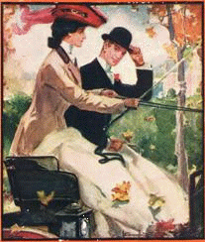
Anyway, it was a terrible nightmare. Terrible things were done to me: I was robbed, then I was beaten, and finally I was killed. But then the nightmare changed into a beautiful dream: I seemed to be in some sort of paradise, where all the people were very beautiful and nice, and I was constantly being hugged and kissed. Have you spotted all the verbs in the passive voice?
I was taken to their leader, who looked a bit like Elizabeth Shue (have you seen Leaving Las Vegas?) and asked me about a million questions: who I was, where I came from, etc.; and after I had told her what had happened to me, she asked me whether my attackers had stolen anything from me, what they looked like and how I had been killed. Check the use of tenses in these indirect questions!
Then only I noticed that this was a community of women and that I was the only man there. Their leader told me that if I had been a woman I could have stayed with them and become a member of their community. But since I was a man, I had to go back to my own country. And I remember waking up with these thoughts on my mind: What would it be like if I were a woman? Would I have completely different thoughts and feelings? Note the use of tenses in the if-sentences.
And now it's your turn. Please tell us about a dream of yours, but make sure your account includes examples of at least 4 grammatical structures that we have practised in this course (just as my little essay contains examples of sentences with ago, for and since, passive constructions, indirect questions and if-sentences).
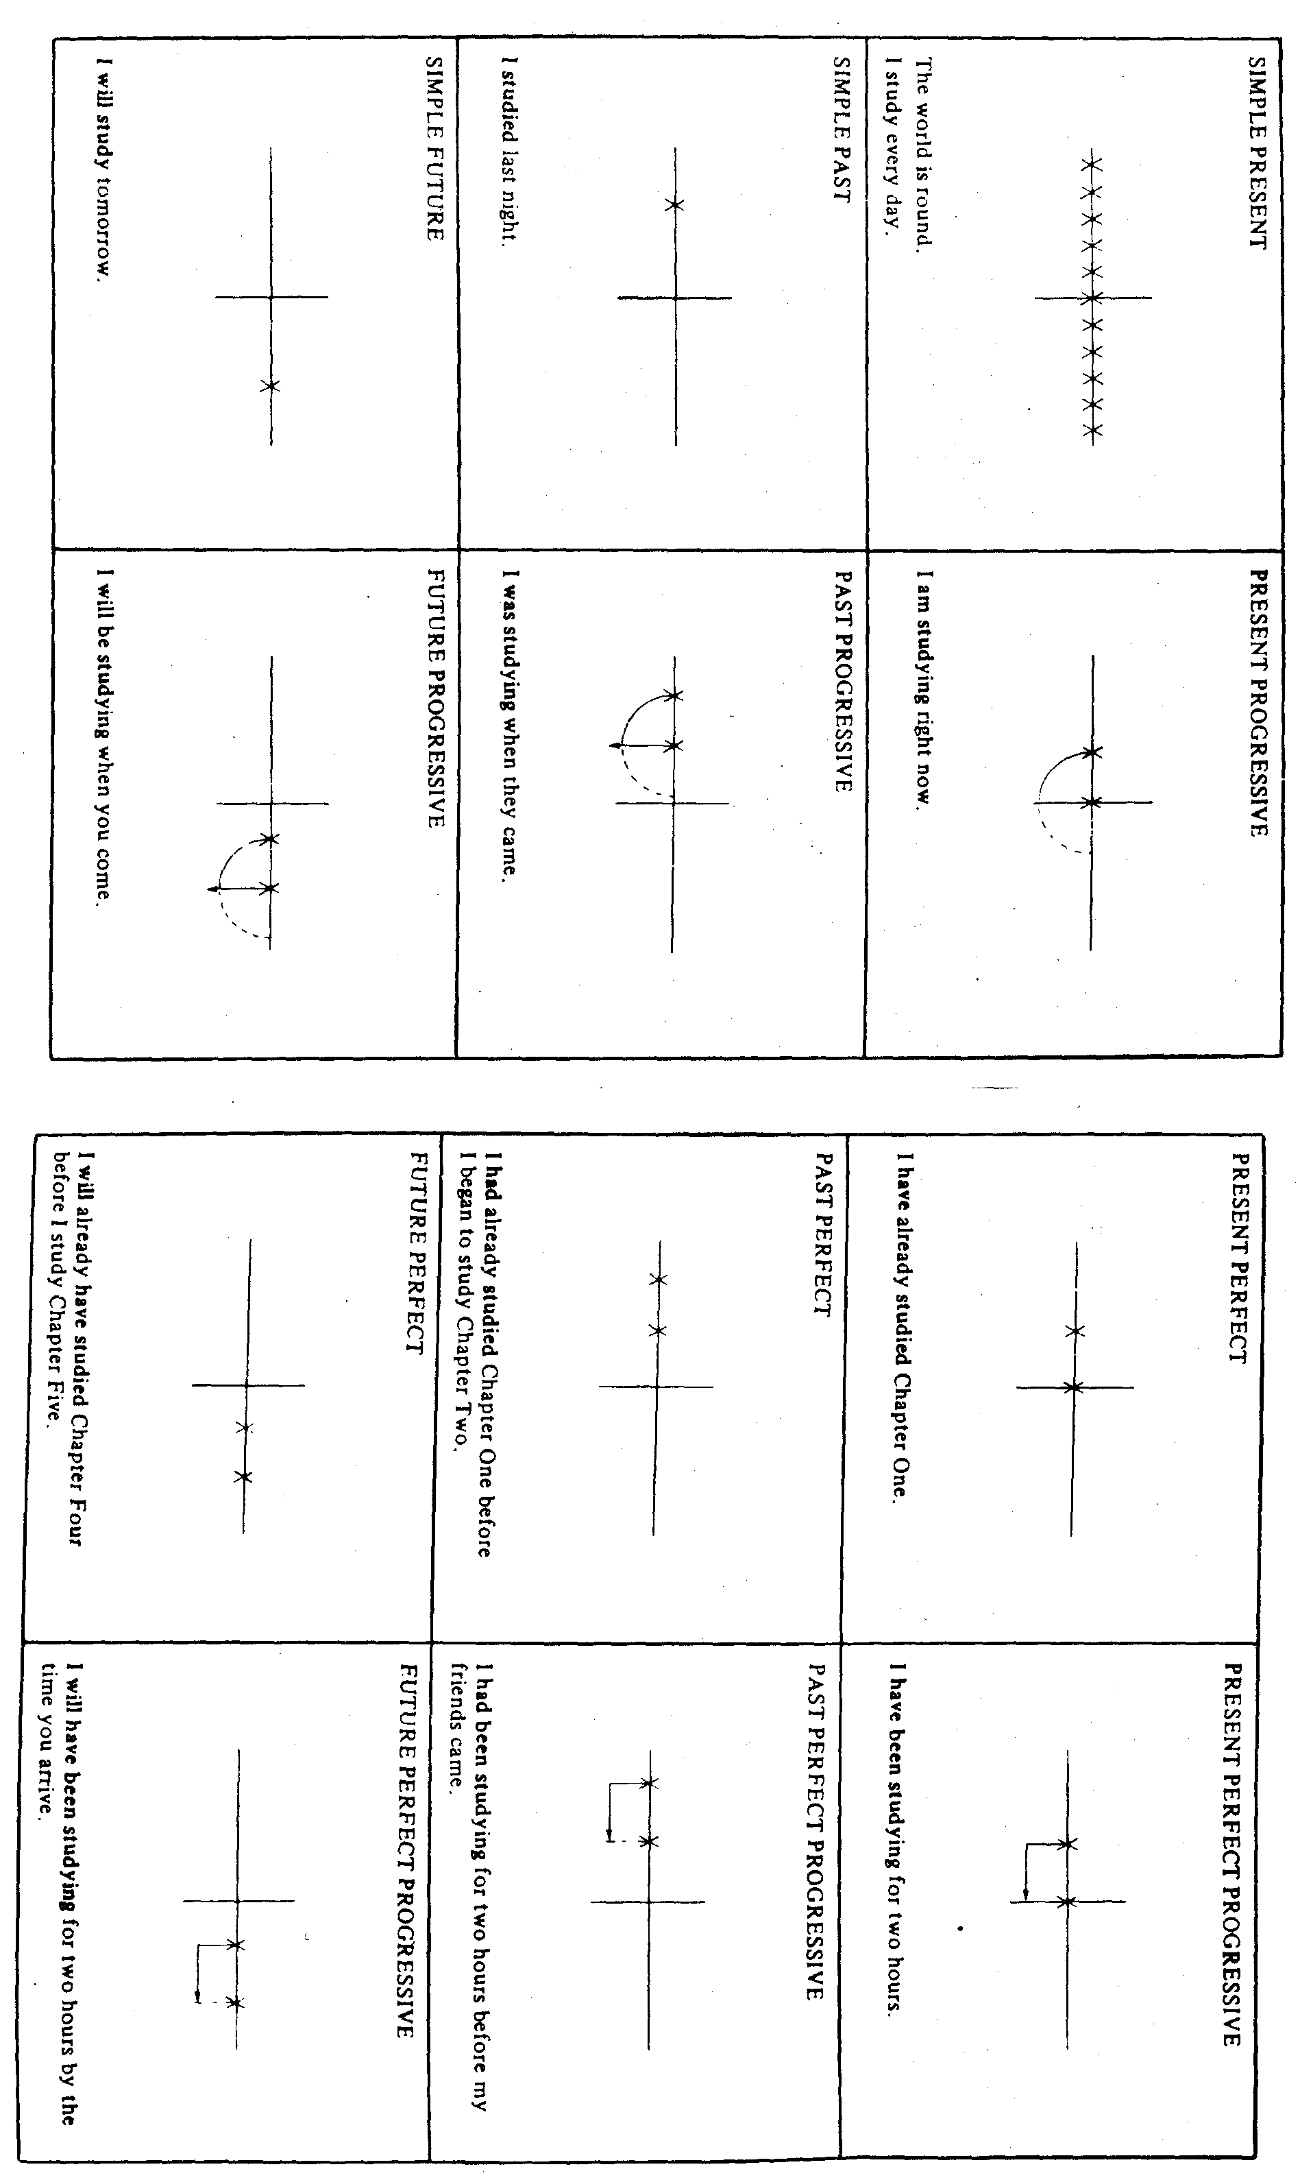
Exercise 1: Answer the questions in complete sentences:

1. What places have you visited since you came to Feldkirch? When?
2. What countries have you been to? When?
3. What programmess have you seen on television? What did you watch last night?
4. What are you doing right now? What is (. …………...) doing? What am I doing?
5. What kind of shoes is (. …………...) wearing?
6. What are you wearing today?
7. What will you be doing tonight at midnight? What were you doing last night at midnight?
8. What are you going to be doing at this time tomorrow?
9. What time are you coming to class tomorrow?
10. Where will you be living three years from now?
11. How long have you been going to school?
12. What have we been doing for the last five minutes?
13. How long have you been sitting in that chair?
14. How long will you have been sitting in that chair by the time class is over?
15. Where are you living? Where were you living five years ago?
16. How long are you going to be living in Vorarlberg? How long will you have been living here by the time you leave?
17. What have I been doing?
18. What have we been studying in class?

EXERCISE 2 Use any appropriate tense for the verbs in parentheses.
- John is in my English class. He (study) _________________ English this semester. He (take, also) _________________ a couple of other classes. His classes (begin) _________________ at 9:00 every day.
- Yesterday John ate breakfast at 8:00. He (eat, already) ________________________ breakfast when he (leave) ______________________ for class at 8:45. He (eat, always) ____________________breakfast before he (go) __________ to class. I (eat, not, usually) ____________________breakfast before I(go) ________________________________ to class. But I (get, usually) _________________ hungry about midmorning. Tomorrow before I (go) _____________________________ to class, I (eat) ____________________ breakfast.
- John is in class every morning from 9:00 to 12:00. Two days ago, I (call) ____________ him at 11:30, but I could not reach him because he (attend) _______________________ class at that time.
- Don't try to call John at 11:30 tomorrow morning because he (attend) _______________at that time.
- Yesterday John took a nap from 1:00 to 2:00. I came at 1:45. When I (get) ____________ there, John (sleep) _________________. -He (sleep) _________________________ for 45 minutes by the time I came.
- Right now John (take) ____________________ a nap. He (fall) _____________________ asleep an hour ago. He (sleep) _______________________________ for an hour.
- Three days ago, John (start) _________________ to read Farewell to Arms, a novel by Ernest Hemingway. It is a long novel. He (finish, not) _______________________ reading it yet. He (read) ___________________________ it because his English teacher assigned it.
- Since the beginning of the semester, John (read) ______________________________ three novels. Right now he (read) ________________________________ A Farewell to Arms. He (read) ___________________________that novel for the past three days. He (intend) _________________________________ to finish it next week. In his lifetime, he (read) ____________________________________ many novels, but this is the first Hemingway novel he (read, ever) ____________________________________.
- Tomorrow, after he (eat) ____________________________ dinner, John (go) _________________________to a movie. In other words, he (eat) _________________ dinner by the time he (go) ______________________________________ to the movie.

EXERCISE 3: Use any appropriate tense for the verbs in parentheses.
1. A: There is something I have to tell you.
B: Go ahead. I (listen) —————————————————.
2. A: Hi, Ann. (Meet, you) ________________________ my friend, George Smith?
B: No, I (have, never) _____________________________ . the pleasure.
A: Then let me introduce you.
3. A: Stop! What (you, do) __________________________________________?
B: I (try) _____________________________ to get this piece of toast out of the
toaster. It's stuck.
A: Well, don't use a knife. You (electrocute)__________________________ yourself!
B: What do you suggest I do?
A: Unplug it first.
- A: There's Jack.
B: Where?
A: He (lie) ____________________________ on the grass under that tree over there. B: Oh yes. I (see) _________________________ him. He (Iook, certainly) ________
___________________________________ comfortable. Let's go talk to him.
5. A: (Take, you) ___________________________ Econ 120 this semester?
B: No, I _______________________________________.
A: (Take, you, ever) _____________________________________ it?
B: Yes, I _______________________________________.
A: When (take) ___________________you _______________________it?
B: Last semester.
A: Who (be) ________________ your professor?
B: Dr. Lee.
A: Oh, I have the same professor. What (be, he) _____________________ like?
B: He (be) ____________________ very good.
6. A: What's wrong with Chris?
B: While he (yawn)————————————————, a fly (fly) ____________ into his mouth.
A: I (believe, not) _______________________________ that! You (kid) ___________
- A: I (go) _________________________ to a play last night.
B: (Be, it) ___________________ any good?
A: I thought so. I (enjoy) ___________________________ it a lot.
B: What (be, it) ______________________________?
A: Arsenic and Old Lace. I (see, never) _________________ it before.
B: Oh, I (see) _______________________________ that play too. I (see) ______
__________________ it a couple of years ago. It (be) ________________________ good, (be, not) _____________________ it?
8. A: I was in your hometown last month. It looked like a nice town. I (be, never)
__________________ there before.
B: What (do, you) _____________________ in that part of the country?
A: My wife and I (drive) ________________________ to Washington to visit her folks.
- A: May I borrow some money? My check (be) _________________supposed to arrive yesterday, but I still (receive, not) ___________________ it. I (need) _____________ to buy a book for one of my classes, but I (have, not) ________________ any money.
B: Sure. I'd be happy to lend you some. How much (need, you)____________________?
A: Five bucks {be} ________________________ enough. Thanks. I (pay)____________
________________ you back as soon as I (get) ______________________ my check.
10. A: Hello?
B: Hello. May I speak to Sue?
A: She (be, not) _______________________________ in right now. May I take a
message?
B: Yes. This is Art O'Brien. Would you please ask her to meet me at the library
this afternoon? I (sit) ________________________ at one of the study booths on the second floor.
EXERCISE 4: Use any appropriate tense for the verbs in parentheses.
- My grandfather (fly, never) ______________________ in an airplane, and he has no intention of ever doing so.
- Jane isn't here yet. I (wait) _______________________ for her since noon, but she still (arrive, not) _________________.
- In all the world, there (be) _____________________________ only 14 mountains that (reach) _________________ above 8,000 meters (26,247 feet).
- I have a long trip ahead of me tomorrow, so I think I'd better go to bed. But let me say good-bye now because I won't see you in the morning. I (leave, already) _____________ by the time you (get) ___________________________________up.
- Right now we (have) ______________________________ a heat wave. The temperature (be) _________________ in the upper 90's for the last six days.
- Last night I (go) _______________________________ to a party. When I (get) __ _________________ there, the room was full of people. Some of them (dance) _________________ and others (talk) _________________. One young woman (stand) _____________________ by herself. I (meet, never)___________________ her, so I _______________________________ (introduce) myself to her.
- About three yesterday afternoon, Jessica (lie)_________________ in bed reading a book. Suddenly she (hear) ______________________ loud noise and (get) ___________ up to see what it was. She (look) _____________________ out the window. A truck (back, just) __________________________ into her new car!
- Next month I have a week's vacation. I (plan) _________________ to take a trip. First, I (go) _________________ to Madison, Wisconsin, to visit my brother. After I (leave) ________________ Madison, I (go) ________________ to Chicago to see a friend who (study) _________________ at a university there. She (live) ______________________ in Chicago for three years, so she (know) ___________________ her way around the city. She (promise) _____________________ to take me to many interesting places. I (be, never) ________________ in Chicago, so I (look) ________________________ forward to going there.
- Yesterday while I (sit) ______________________ in class, I (get) __________________ the hiccups. The person who (sit)__________________________ next to me told me to hold my breath. I (try)___________________________ that, but it didn't work. The instructor (lecture)__________________________ and I didn't want to interrupt him, so I just sat there trying to hiccup quietly. Finally, after I (hiccup)__________________ for almost five minutes, I (raise) _________________________ my hand and (excuse) ______________________ myself from the class to go get a drink of water.
- The weather has been terrible lately. It (rain)________________________ off and on for two days, and the temperature (drop)___________________ at least twenty degrees. It (be)___________________________ in the low 40's right now. Just three days ago, the sun (shine) ___________________________ and the weather was pleasant. The weather certainly (change) ___________________________ quickly here. I never know what to expect. Who knows? When I (wake) _____________________________ up tomorrow morning, maybe it (snow) ____________________________.

EXERCISE 5 Use any appropriate tense.
- On June 20th, I returned home. I (be) ____________________________________
- away from home for two years. My family (meet) ___________________________
- me at the airport with kisses and tears. They (miss)_____________________________
- me as much as I had missed them. I (be) ___________________________ very
- happy to see them again. When I (get) ______________________________ the
- chance, I (take) ___________________________ a long look at them. My little
- brother (be) ______________________________ no longer so little. He (grow)
- _________________ at least a foot. He (be) ___________________________
- almost as tall as my father. My little sister (wear) ________________
- a green dress. She (change) _________________ quite a bit, too, but
- she (be, still) ________________ mischievous and inquisitive. She
- (ask) ________________ me a thousand questions a minute, or so
- it seemed. My father (gain) _________,________ some weight, and
- his hair (turn) ________________ a little bit grayer, but otherwise
- he was just as I had remembered him. My mother (look) ____________
- a little older, but not much. The wrinkles on her face (be) ___________
- smile wrinkles.

EXERCISE 6: Use any appropriate tenses.
- On June 20th, I will return home. I (be) ____________________
- away from home for two years by that time. My family (meet)
- _______________ me at the airport with kisses and tears. They
- (miss) ________________ me as much as I have missed them. I
- (be) ————————————————— very happy to see them again. When
- I (get) __________________ a chance, I (take) __________
- a long look at them. My little brother (be, no longer) ___________
- so little. He (grow) _________________ at least a foot. He (be)
- _________________ almost as tall as my father. My little sister
- (wear, probably) ____________________________ a green dress.
- She (change)________________ quite a bit, too, but she (be, still)
- ____________________ mischievous and inquisitive. She (ask, probably)
- ______________________ me a thousand questions a minute, or so
- it will seem. My father (gain, probably) _____________________________ some
- weight, and his hair (turn) _________________ a little grayer, but
- otherwise he will be just as I remember him. My mother (look)
- _________________ just the same. Perhaps she (look)
- __________________________ a little older, but not much. The wrinkles on
- her face (be) ________________________ smile wrinkles.

EXERCISE 7 Use any appropriate tenses.
- Dear Ann,
- I (receive) _________________ your letter about two weeks
- ago and (try) ________________ to find time to write you back
- ever since. I (be) _________________ very busy lately. In the past
- two weeks, I (have) _________________ four tests, and I have
- another test next week. In addition, a friend (stay) ______________
- with me since last Thursday. She wanted to see the city, so we (spend)
- _________________ a lot of time visiting some of the interesting
- places here. We (be) _________________ to the zoo, the art
- museum, and the botanical gardens. Yesterday we (go) ____________
- to the park and (watch) _____________________ a balloon race.
- Between showing her the city and studying for my exams, I (have, barely)
- —————————————————enough time to breathe.
- Right now it (be) _________________ 3 A.M. and I (sit)
- ________________ at my desk. I (sit) ____________
- here five hours doing my studying. My friend's plane (leave)
- ________________ at 6:05, so I (decide) ______________________
- not to go to bed. That's why I (write) ________________ you at
- such an early hour in the day. I (get) ________________ a little
- sleepy, but I would rather stay up. I (take) ______________ a
- nap after I (get) _________________ back from taking her to the
- airport.
- How (get, you) ____________________ along? How (go, your
- classes) _________________? Please write soon.
Yours truly,
EXERCISE 8 Use any appropriate tense.
A: Hi, my name is Jose.
B: Hi, my name is Ali.
- Jose: (You, study) _________________________________ at this university?
- Ali: Yes, I _____________________. _______________ you?
- Jose: Yes, I (be) _________________________ here since last September.
Before that I (study) ______________ English at another school.
- Ali: What (you, take) _________________________?
- Jose: I (take) _______________________________ chemistry, math, psychology, and American history. What (take, you) ________________________________?
- Ali: I (study) _________________________ English. I (need) _____________________ to improve my English before I (take) ________________ regular academic courses next semester.
- Jose: How long (you, be) _____________________________here?
- Ali: I (be) _________________________ here since the beginning of this semester. Actually. I (arrive) __________________________in the United States six months ago, but I (study) _____________________________ English at this university only since January. Before that I (live) ________________ with my brother in Washington, D.C.
- Jose: You (speak) ———————————————— English very well. (You, study) ________________ a lot of English before you (come) _____________ __ to the United States?
- Ali: Yes. I (study) ———————————————— English for ten years in my own country. And also, I (spend) ________________ some time in Canada a couple of years ago. I (pick) ________________________ up a lot of English while I (live) ________________ there.
- Jose: You (be) _______________________lucky. When I (come) ________________ to the United States, I (study, never) ________________ any English at all. So I had to spend a whole year studying nothing but English before I (start) ______ school.
- Ali: How long (you, plan) ______________________________ to be in the U.S.?
- Jose: I (be, not)_________________________________ sure. Probably by the time I (return) ________________ home, I (be) ___________ here for at least five years. How about you?
- Ali: I (hope) ________________to be finished with all my work in two and a half years.

EXERCISE 9:
.Put the verbs in brackets into the correct tenses.
- They _____________________________________ your lessons. (not like)
- While we _____________________________ to the station it _________________to snow, (drive) (begin)
- Watch this runner. He _______________________________ (win).
- After the centre forward ______________________________ the first goal the fans __________________ mad (score) (go)
- I _____________________________ a shooting star ( never see)
- We ______________________________ the results tomorrow. (know)
- Diana _______________________________ Beethoven's moonlight sonata last night. (play)
- She _____________________________ you are an old fool. (think)
- Bob __________________________ three letters since breakfast. (write)
- Kate _______________________________________ in London (not live)
- She _____________________________ me an answer when I asked her. (not give)
- After Jane _________________________________ a fashion magazine she ____________ the piano, (read) (practise)
- Our landlady ___________________________ us a cup of tea last night. (give)
- Mr Brightwell ______________________________(phone) his secretary all day long .
- I _________________________ any dressmaking since I left school, (not do)
- Mr Bellows _____________________ from the USA. (just arrive)
- Mr Brown __________________________________ a letter every day. (write)
- Mrs Mauldling __________________________ the letter immediately after she ___________________________it (post) (finish)
- The Smiths ________________________________ yet. (not come)
- I __________________________________ two exercises, would you like to do the third? (correct)
- Richard usually_____________________________ a pullover but when I ______________ him last night he _____________________ a coat. ( wear) ( see) (wear)
- _______________________________________to Mexico? (you, ever, be)
- I ______________________________ to Jane since last Monday. (not write)
- ___________________________to phone you last night? (Bob try)
- I _______________________________________ this play before. (not see)
- Jeffrey thanked his father for what he ______________________________ for him. (do)
- Mary and Lizzy ________________________________ the poem all afternoon. (learn)
- Bob ___________________________________ football all the afternoon. (play)
- They’d better come in. It __________________________________ to rain (begin)
- Bettie ______________________ his coat last night. (tear)
- The Second World War ________________________________ in 1939. (begin)
- Your coat ____________________________________ there the whole afternoon. (lie)
- The postman _____________________________ the post every day. (bring)
- She __________________________________________________ you (soon forget)
- I __________________________________ a coat because it's too hot today. (not wear)
- Lizzie and Dolly _________________________________ at six this morning, (wake up)
- We ________________________________________ an answer last night. (not get)
- My parents ____________________________________ in Berlin since 1980. (live)
- "How___________________________________ at school? -I ______________ very well (Bob get on) ( believe)
- Jaqueline __________________________ why I ___________________________ earlier. (wonder) (write)
- ___________________________________________ the film last night? (you see)
- We need not run. ___________________________________ the bus ( you see). It __________________ the bus station (just leave)
- I _________________________________ a letter (write) when Fred ________________ the room (enter)
- Peter __________________________________ his best now. (try)
- I ________________________________ the work tomorrow. (do)
- I couldn't answer the phone because I ___________________________ a shave. (have)
- I can't understand what you ________________________________. The traffic is too noisy. (say)
- Mathews ____________________________ an interesting play most of the evening. (watch)
- Peter suddenly ___________________ that he ___________________ his cap in the train, (realize) (leave)
- He ___________________________________________ next week. (not come)
- Before he ________________________ away he _____________ a letter. (go) (write)
- Bob _______________________________ tennis very well. (not play)
- When I __________________________him he___________________ to Helen, (see) (talk)
- You need an umbrella. It ________________________________________ (rain)
- She ___________________ stay up later than nine yesterday, (mustn't)
- I __________________________________ finish my work last night. (must)
- We _______________________ this letter before he ___________________ home (can translate) ( go)
- John ______________________ do it now. I ________________________ it later, (not need) (do)

