**Arc Force Adjustments**

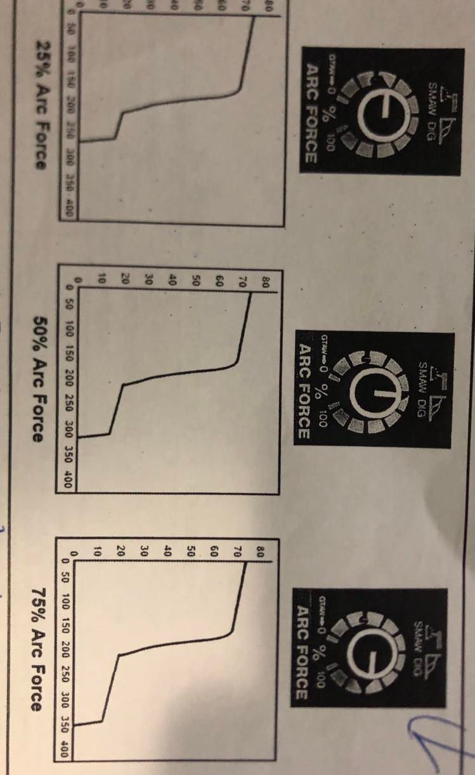

Each welder will have his own ideas on where to set the arc control for different types of electrodes. For open root welds on plate or pipe electrode would be selected for the first pass. By adding arc control, usually toward the high end of the scale, the welder has the ability to control amperage by arc length. All it need to be done is decrease arc length and the amperage will increase. For electrodes that are not used for open root welds the welder should increase arc control to the point where the electrodes don’t stick. For carbon arc gouging, setting arc control to maximum will reduce stubbing. When using voltage sensing feeders on CC machines for flux cord wires, increasing arc control can improve starts.

For TIG welding, the load voltage is typically between 10 to 16 volts with argon shielding gas. Arc control can keep electrodes from sticking, can increase penetration, and can eliminate a lot of operator frustration.

**HOW TO START**

When this feature is selected 70 to 100 additional amps are automatically provided for 1/10 of 1 second at the arc starting. Hot start is used for shielded metal arc welding and air carbon arc cutting processes.

The core of the covered electrode consists of either a solid metal rod of drawn or cast material or one fabricated by encasing metal powders in a metallic sheath. the primary functions of the electrode covering are to provide arc stability and to shield the molten metal from the atmosphere with gases created as the coating decomposes from the heat of the arc. The shielding along with other ingredients largely controls the mechanical properties chemical composition and metallurgical structure of the weld metal, as well as the arc characteristics of the electrode. To increase the deposition rate the covering of some carbon and low alloy steel electrodes contain iron powder. The presence of iron powder in the covering also makes more efficient use of the arc energy. Iron powder electrodes with thick covering reduce the level of skill needed the weld.

SMAW electrodes are available to Weld carbon and low alloy steels, stainless steels, cast irons, copper, and Nickel and their alloys, and for some aluminium applications. Low melting metals such as lead. tin and zinc, and their alloys, are not welded with SMAW because the intense heat off the arc is too high for them.

