SHIELDED METAL ARC WELDING

Shielded Metal Arc Welding is an arc welding process in which coalescence of metals is produced by heat from an electric arc that is maintained between the tip of a consumable electrode and the surface of the base metal in the joint.

Shielded Metal Arc welding is usually used for short welds in production, maintenance and repair work, and for field construction.

advantages of this process:

1. The equipment is relatively simple, inexpensive, and portable.

2. The filler metal, and the means of protecting it and the weld metal from harmful oxidation during welding, are provided by the covered electrode.

3. The process is less sensitive to wind and draft than gas shielded arc welding processes.

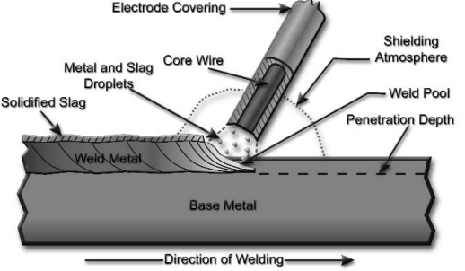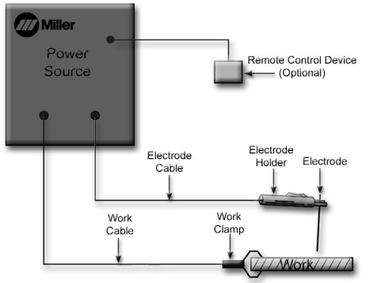PRINCIPLES OF OPERATIONThe electrode and the work are part of an electric circuit. One of the two cables from the power source is attached to the work. The other is attached to the electrode holder. The intense heat of the arc melts the tip of the electrode and the surface of the work close to the arc.